 Updating M-4 Information

Begin by navigating to the M-4 (MA State) Tax Information page by clicking on the “M-4 (MA State) Tax Information” tile

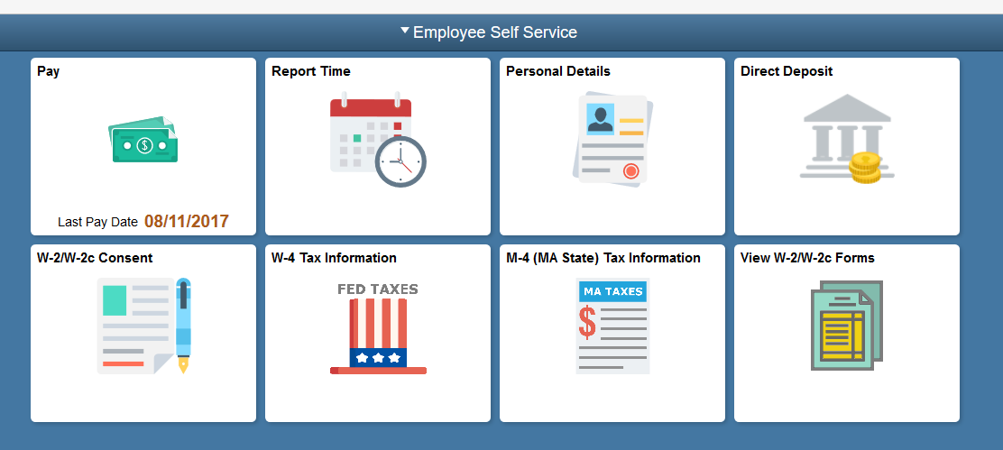

Enter the desired information into the Enter total number of Allowances you are claiming field.

Enter a valid value e.g. "1".
If you want to have an additional amount withheld from each paycheck, you would enter the amount in this field.
Enter the desired information into the Enter Additional Amount, if any, you want withheld from each paycheck field.

Enter a valid value e.g. "40.00".
Click the scrollbar.

Click a radio button or buttons for the State Withholding Status you are claiming.

Click the Claim Exemption checkbox if you claim an exemption from Massachusetts withholding tax.

Note: You must not be claiming an Allowance and you are not requesting an Additional Amount to be withheld from each paycheck.
Click the Submit button.
Click the OK button.
Your updates display on the page.

Congratulations! You have successfully updated your M-4 information.
End of Procedure.

