 Maintaining Personal Email Addresses

Click on the “Personal Details” tile
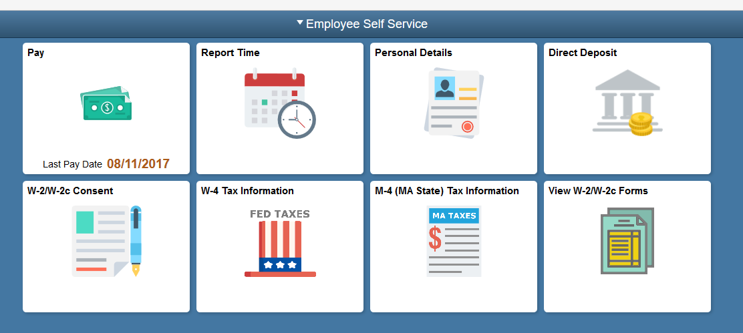
Click the Contacts Detail link.

In this exercise, you are going to add a new email address.

Note: You cannot delete your work email address.
Click the 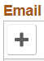plus button under Email

Click the Email Type list box.
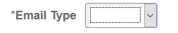
Click the Other list item.
Enter the desired information into the Email Address field.

Enter a valid value e.g. "fflintstone@gmail.com".
Click the Save button.
Your additional email address has been added to the Email Addresses page.
Congratulations! You have successfully updated your email address information.
End of Procedure.

