

Enrolling in Direct Deposit

Begin by navigating to the Direct Deposit page by clicking on the “Direct Deposit” tile

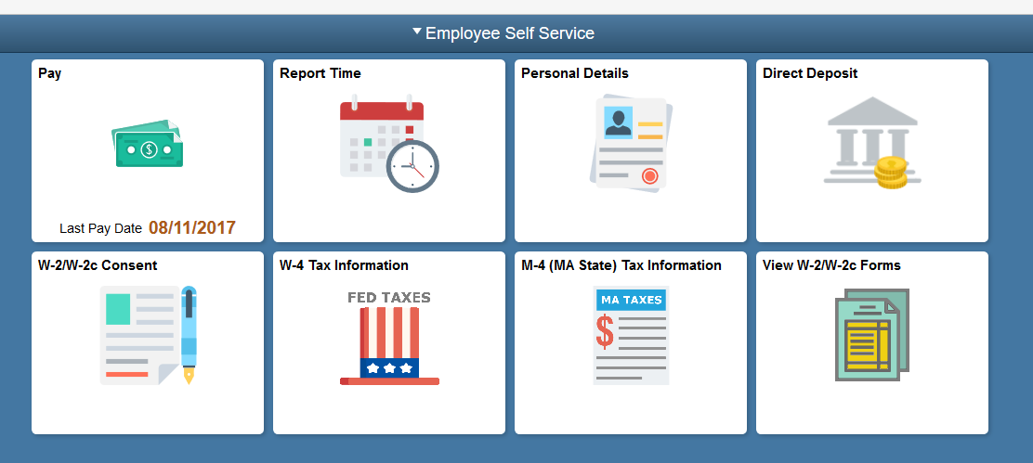
Use the Direct Deposit page to view current direct deposit information or to add a new account.
If you already have a direct deposit account, you will need to verify the existing account information before you can make any updates.
No accounts currently exist for you. You need to add an account.

Click the Add Account button.
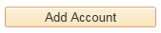
Enter the desired information into the Routing Number field.

Enter a valid value e.g. "011000138".
You can get this information from your personal checks. If you're not sure how to read this information, click the View check example link.
Enter the desired information into the Account Number field.

Enter a valid value e.g. "12345678".
Use the Account Type field to select the type of account you will now be adding.

Click the Account Type list.
You can select from different types of accounts, such as Checking and Savings.

Click the Checking list item.
Use the Deposit Type field to specify whether you would like to deposit a flat amount, a percentage, or the balance of your pay.

Click the Deposit Type list.
You can specify a flat amount, percent or balance.

If only one account is used, you must select balance.

If multiple accounts are used, you must specify the account used for the balance of the paycheck amount first. For example, you might deposit 10% into a savings account and the remaining net pay into a checking account.
Click the Balance list item.
The Deposit Order field will default to '999' for deposit type of 'Balance', which will display upon saving the page.

Click the Save button.
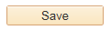
Your checking account information has been saved and displays on the Direct Deposit page.
Congratulations! You have successfully enrolled in Direct Deposit.
End of Procedure.

