 Maintaining Personal Phone Numbers

Click on the “Personal Details” tile
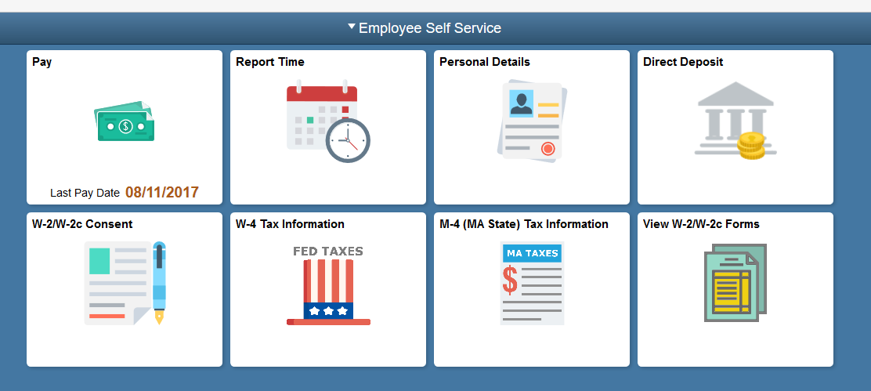
Click the Contact Details link.
Use the Contact Details page to view, add, update, and delete phone numbers.
You can modify existing rows by clicking on the phone number to be changed, updating the fields and clicking the Save button.

Note: Business phone numbers cannot be changed using Employee Self Service.
To add a new phone number, click the Plus sign icon
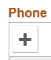
Use the Phone Type list to select the type of phone number you will be entering.

Click the Phone Type list.
Click the Mobile list item.
Enter the desired information into the Telephone field.

Enter a valid value e.g. "978/444-7890".
Click the Save button.

Review the change you've made.
Congratulations! You've successfully added a phone number to your personal information.
End of Procedure.

