Step | Action
Logon to HR Direct Department Self Service:
Click Start a New ePAF

Click Change Employment Status.
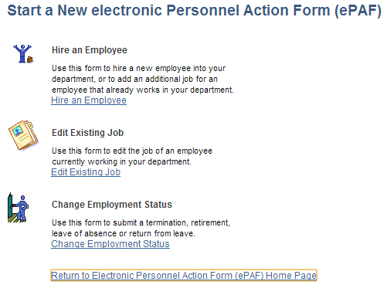
Enter in the Employee ID and Record Number or you can search by Name.
Update Job Data with information provided and click NEXT. If no changes to Job click NEXT to continue updating form.

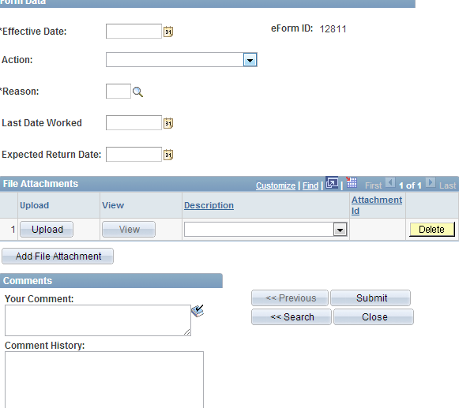
 | Click Submit
 | END PROCEDURE FOR JOB STATUS CHANGE.

