Step | Action
Logon to HR Direct Department Self Service:
Click Start a New ePAF
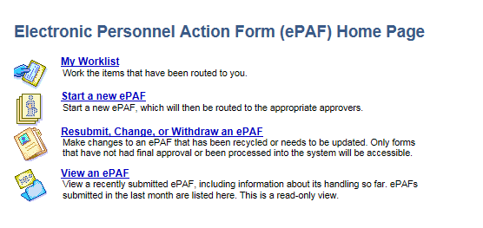
Click Edit Existing Job.
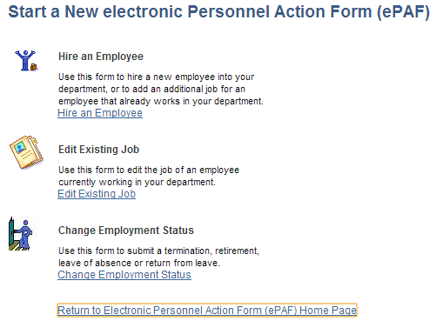
Enter in the Employee ID and Record Number or you can search by Name.
Update Job Data with information provided and click NEXT. If no changes to Job click NEXT to continue updating form.

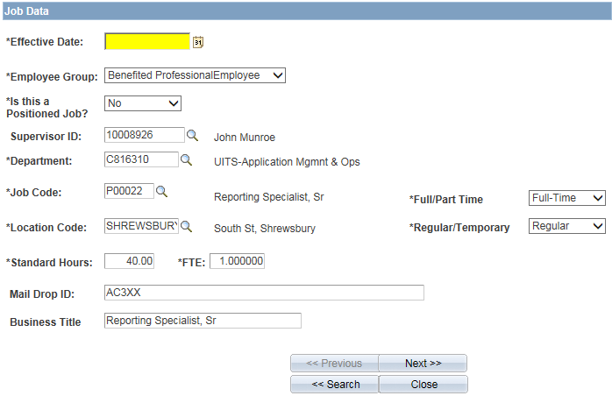
Update Compensation Data as provided
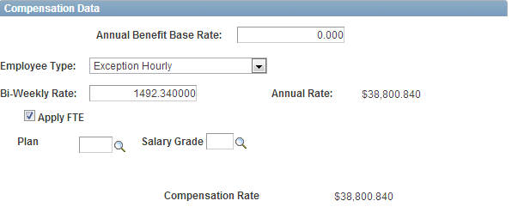
Update GL data as needed and Click NEXT.
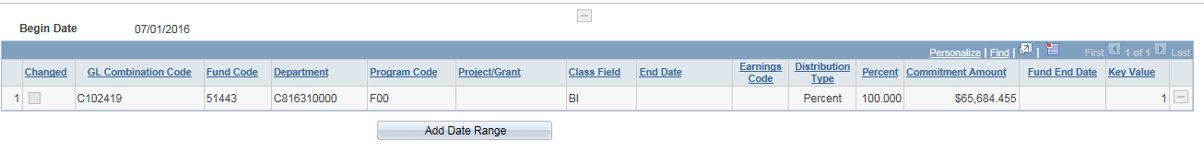
Update Time and Labor data as needed and Click NEXT.
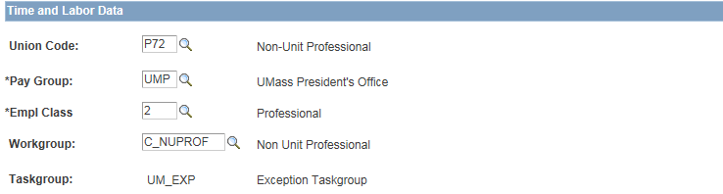
Finalize form updating Action/Action Reason as appropriate and click SUBMIT if complete or Save for Later if more information is needed.
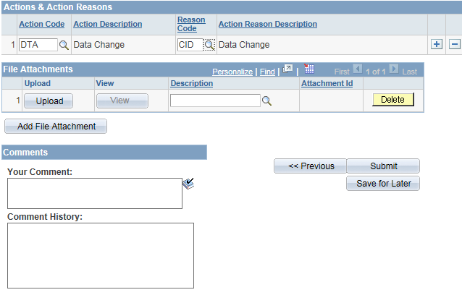
 | END PROCEDURE FOR REPORTING EXCEPTION TIME

