HR Direct – MANAGER TIME APPROVAL

1. | Navigate to Manager Self Service/Time Management/Approve Time and Exceptions/Payable Time
2. | 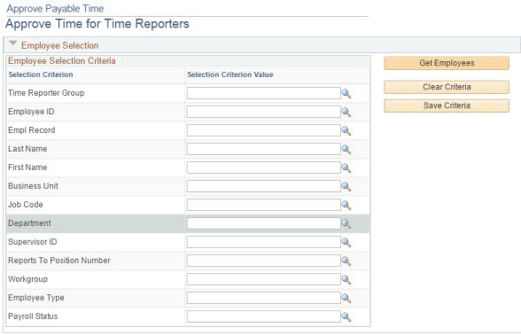
3. | Click on the Search icon for the Time Reporter Group
4. | 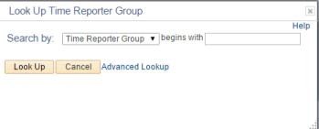
5. | Click on Look Up.
6.
7. | Click on your Zgroup value – it will start with Zxxxx and the description will include Approval – your name
Note: | Do not save this value as it may change on a regular basis

8. | Click on
9. | 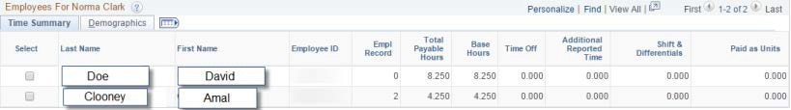
10. | Review Summary of Time Submitted. If you agree with the totals, click , then  .
11. | If you want to review details of the time entered day by day click onto the name and the detail page will open.
12. | 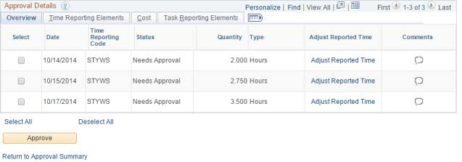
Note: | If time has been changed after a prior Approval, you will see the adjustments as negative and the new entry row as a positive.
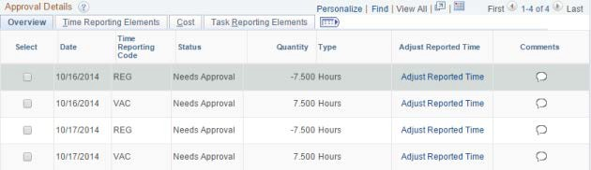
13. | You can select and approve individual rows or click on Select All and approve all rows or click Return to Approval Summary without approving any rows.
Note: | If you have direct reports that also are supervisor, you may use their Z Group as search criteria to approve their employees if needed.

