Recording Time for an Exception Time Reporter
- From the Main Menu begin by navigating Management Self Service. Click the Time Management link.

- Click the Report Time link.

- Click the Timesheet link.

- Use the Employee Selection Criteria section of the Timesheet Summary page to select a group of employees, or an individual employee, for time entry.

- You may be able to click the Get Employees button without entering any criteria on this page, as they will only have access to their time reporters. Others may need to enter one or more selection criteria in the fields provided. An example is a Group ID or Supervisor ID.

- Enter the criteria to select the employee(s) according to your campus business practice. For this example, enter the Employee’s Last Name into the Last Name field.

- The Date field defaults to the current date. Change the date to the pay period begin date (Sunday). Enter a Sunday start date e.g. "MM/DD/YYYY".

- Click the Get Employees button.

- The employee(s) matching your criteria displays at the bottom of the page. Click an entry in the Name column.

- Use the Timesheet page to enter time, adjust reported time, or view time. The week is displayed from Sunday through Saturday.

- To populate the grid with the employee's scheduled time, click the Apply Schedule button.

- The employee's regular schedule displays with the appropriate Time Reporting Code. In this example, the schedule should be adjusted for sick time. To adjust the schedule, click the Add a Row button

- Select the time displayed for day your employee is out sick in the first row.

- Press [Delete] to eliminate the regular hours.

- In the new row, enter the desired information in the day the employee is out sick. Enter a valid value for hours e.g. "8". Note: Entries for each day, in each row, should equal the scheduled daily hours for the employee.

- Click the Time Reporting Code list.

- Select the appropriate TRC for the leave time, comp time, or pay differential according to your campus business process. For this example, click the SIC - Sick Time list item.

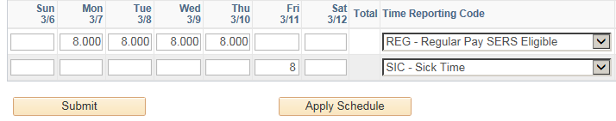

- Click the Submit button.

21. Click the OK button.

