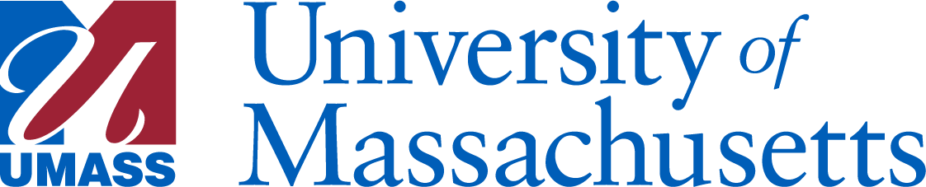

From: Chair Stephen Karam and President Marty Meehan
To: UMass Chan Community
Subject: UMass Chan Chancellor Search

Dear members of the UMass Chan community,
As you know, Chancellor Michael F. Collins announced his plan to step down as chancellor at the end of this academic year. For nearly two decades, Chancellor Collins has been at the helm of UMass Chan Medical School during a period in which the Medical School has become a world-renowned institution, and we are grateful to him for his many contributions.
We’ve long believed that UMass Chan Medical School is a gem of the University of Massachusetts system and ensuring that its next leader is both worthy of this incredible community and capable of leading it through this challenging moment is our top priority.
Therefore, we are writing today to inform you that we have taken the first step in that process by appointing the UMass Chan Chancellor Search Committee, which will convene for the first time this afternoon. The Search Committee’s first task will be to engage with the UMass Chan community to solicit input and feedback in order to identify the qualities and strengths necessary for the next leader. From this initial assessment, the Search Committee will build the position profile that will be used to identify the best potential candidates for the role.
We have appointed UMass Trustee David Brunelle, a long-time Worcester County resident and business leader, to serve as the chair of the Search Committee and to lead its important work. The 20-member Search Committee is comprised of local leaders who have strong ties to the Medical School and are dedicated to its mission and future success.
The Search Committee members are:
- Chair: David M. Brunelle
Trustee, UMass Board of Trustees
- Rita K. Amoah, RN, PhD ’21
Assistant Professor
- Bethany Berry
MD/PhD Candidate;
UMass Chan Student Trustee
- Mary Burns, UMass Lowell ’84
Vice Chair, UMass Board of Trustees;
Chair, UMass Building Authority Board
- Katherine Craven
Executive Vice President, Administration and Finance, Babson College;
Director, UMass Foundation Board of Directors;
Chair, Board of Elementary and Secondary Education
- Edward H. D’Alelio, UMass Boston ’74
Treasurer & Investment Committee Chair, University of Massachusetts Foundation
- Katherine A. Fitzgerald, PhD
Professor and Vice Chair, Department of Medicine;
Vice Provost for Basic Science Research;
Worcester Foundation for Biomedical Research Chair III
- James R. Julian, Jr, JD
CEO, University of Massachusetts Foundation
- Katherine Luzuriaga, MD
UMass Memorial Health Care Endowed Chair in Biomedical Research;
Vice Provost for Research
- Justin A. Maykel, MD
Joseph M. Streeter and Mary Streeter DeFeudis Chair of Surgery;
Professor of Surgery;
Chief, Division of Colon and Rectal Surgery
- Craig C. Mello, PhD
Distinguished Professor;
Blais University Chair in Molecular Medicine;
2006 Nobel laureate
- Timothy P. Murray, JD
Former Lieutenant Governor of Massachusetts;
President and CEO, Worcester Regional Chamber of Commerce
- Noreen C. Okwara, UMass Boston ’12, MD ’17
UMass Board of Trustees
- R. Norman Peters, JD, ’04 (H)
Partner, Peters & Sowydra;
Director, UMass Foundation Board of Directors;
Member, UMass Building Authority Board
- Karyn Polito, JD
Former Lieutenant Governor of Massachusetts;
Vice President of Business Development, UMass Memorial Health
- Javier A. Reyes, PhD
Chancellor, University of Massachusetts Amherst
- Michael P. Stauff, MD
Chair, Department of Orthopedics and Physical Rehabilitation;
Donna M. and Robert J. Manning Endowed Chair in Orthopedics;
Associate Professor of Orthopedics
- A.J. Marian Walhout, PhD
Professor and Chair, Department of Systems Biology;
Maroun Semaan Chair in Biomedical Research
- Marcellette G. Williams, PhD
UMass Amherst Chancellor Emerita;
Retired Senior Vice President for Academic Affairs at the UMass President’s Office
- Charles F. Wu
Trustee, UMass Board of Trustees;
Member, UMass Building Authority Board

*Stephen R. Karam, ex-officio
Chair, UMass Board of Trustees

We are pleased that we have been able to appoint a Search Committee that is representative of this special institution and community and would like to thank the members of the appropriate campus governing bodies for their recommendations for Committee members.
We have also retained the national executive search firm - Isaacson, Miller - to assist the committee with its work. The Isaacson, Miller team includes: John Isaacson, Stephanie Fidel, Cam Patterson, Nick Strand, Ibaad Nazeer, and Mindy Cimini.
In the weeks and months ahead, you will hear from Search Committee Chair Brunelle and members of the Committee about the search process as it progresses, both to keep you fully informed and to ensure that you have ample opportunity to weigh in and provide feedback. Your contributions and engagement to this search will help ensure its success.
The first meeting of the Search Committee will be held later today, Wednesday, September 17 at 3:00pm. It will be a remote meeting and can be joined via this link: https://umassp.zoom.us/j/96739149958.
The Search Committee will also post information about its meetings, documents, and its work on the Search Committee website at www.umassp.edu/chancellorsearch.
We thank you in advance for your contributions to this process, and for all that you do to make UMass Chan the special place that it is.
Sincerely,
Stephen Karam, Chair, UMass Board of Trustees
Marty Meehan, President, University of Massachusetts

University of Massachusetts
Office of the President
One Beacon Street, Floor 32
Boston, MA 02108

