Step | Action
Logon to HR Direct Department Self Service:
Click Start a New ePAF
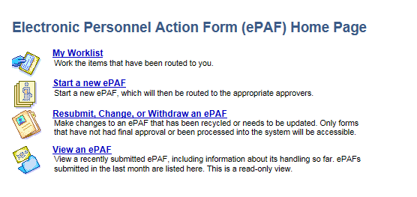
Click Hire an Employee.
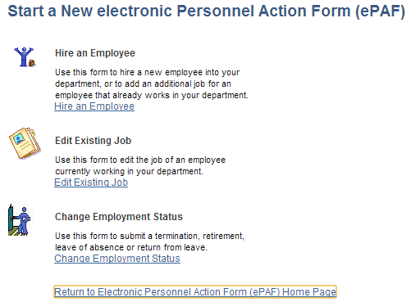
 | 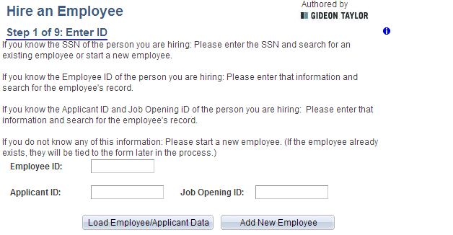
Use the Hire an Employee page to start the Hire process.
Best business practice is to have a 2nd window open for Search/Match to confirm if the person already exists in the system.
 | If you have the Employee ID or Applicant ID, enter here and click . If this is new person, click
 | Enter the requested information as provided by personal information forms and click NEXT.
 | 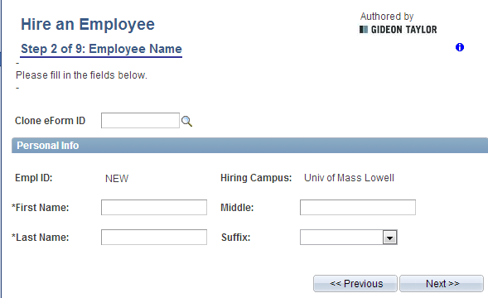
 | Job Information. Depending on Employee Group and if Positioned Job selected in Drop Down you may have different required values. Review your business requirements and forms provided to determine appropriate selections. Once fields are completed, click NEXT.
 | 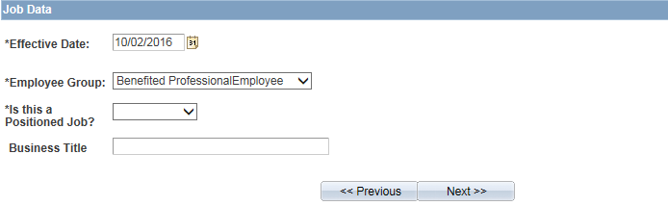
 | 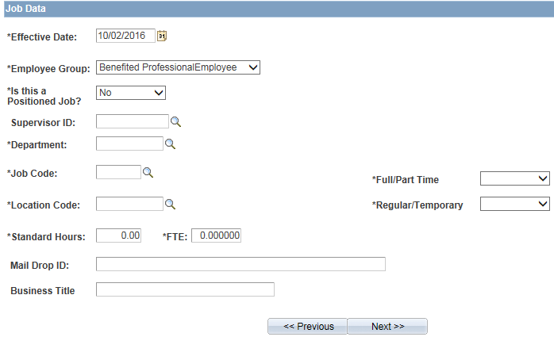
Fill in Compensation Fields as appropriate to the job/position data provided.
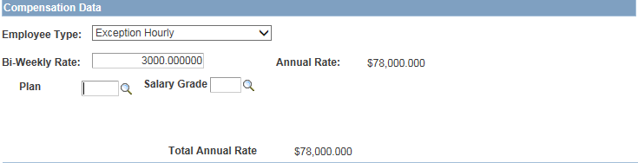
 | Enter GL Information as needed. If Percent is chosen for Distribution type you will need to account for 100% either in single or multiple rows. If Amount is chosen, enter amount as provided.
Enter Actions/Action Reasons as needed. Remember to check the Attach Hire Documentation acknowledgement box.
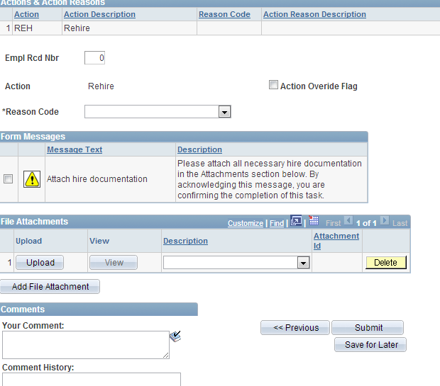
If form is complete, click Submit. If more information is needed click Save for Later and return to form when information is available.
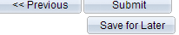
 | END PROCEDURE FOR EPAF HIRE

