BuyWays ProCard Electronic Reconciliation Process

Contents
Creating an electronic ProCard reconciliation 1
Revising a returned requisition 16
Reviewing an electronic ProCard reconciliation for approval 21
Submitting a requisition as approved 31
Returning a requisition to the creator for revision 33
Requisition Document Search 35

Creating an electronic ProCard reconciliation

- Navigate to the UMass Connect To page https://www.umassp.edu/connect
and click the UMass BuyWays link under Finance to log in to BuyWays.

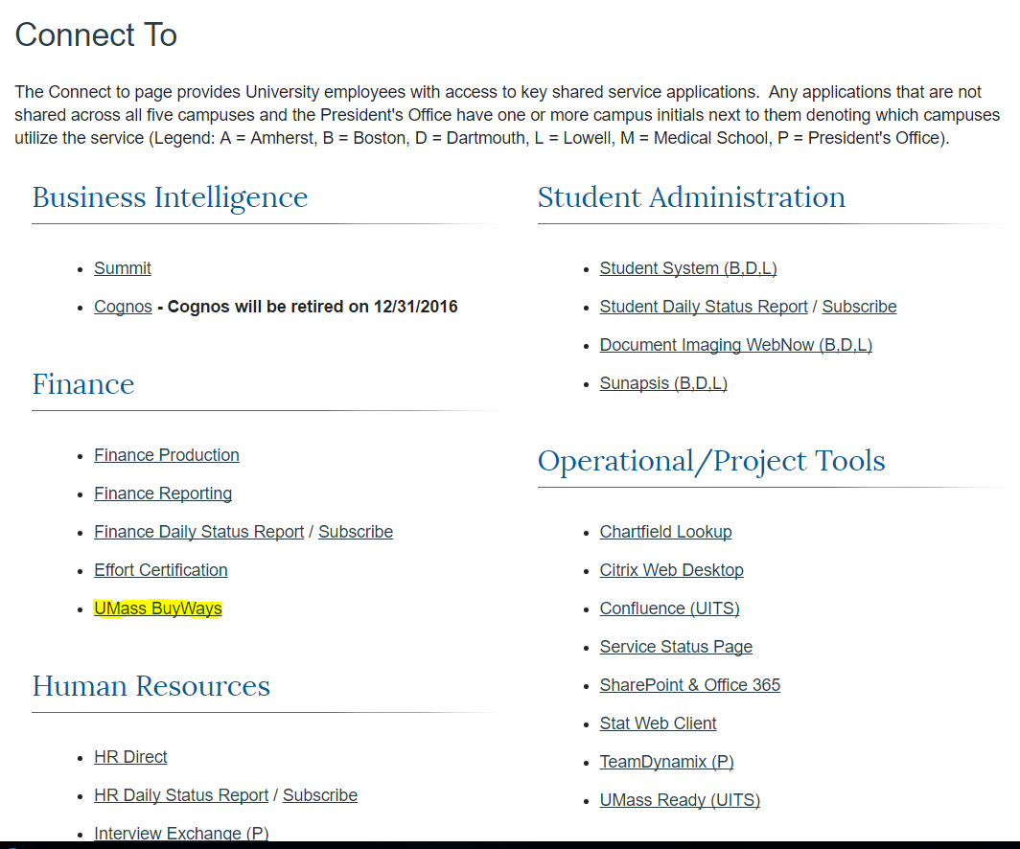

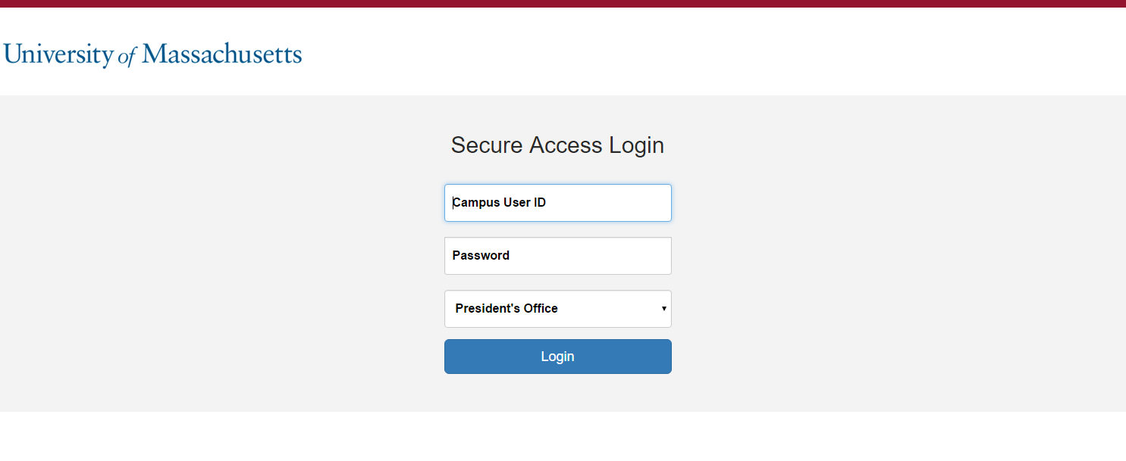

- Once logged in to BuyWays, click the ‘Forms’ hyperlink on the Go To menu to navigate
to the ProCard Transaction Log Form.

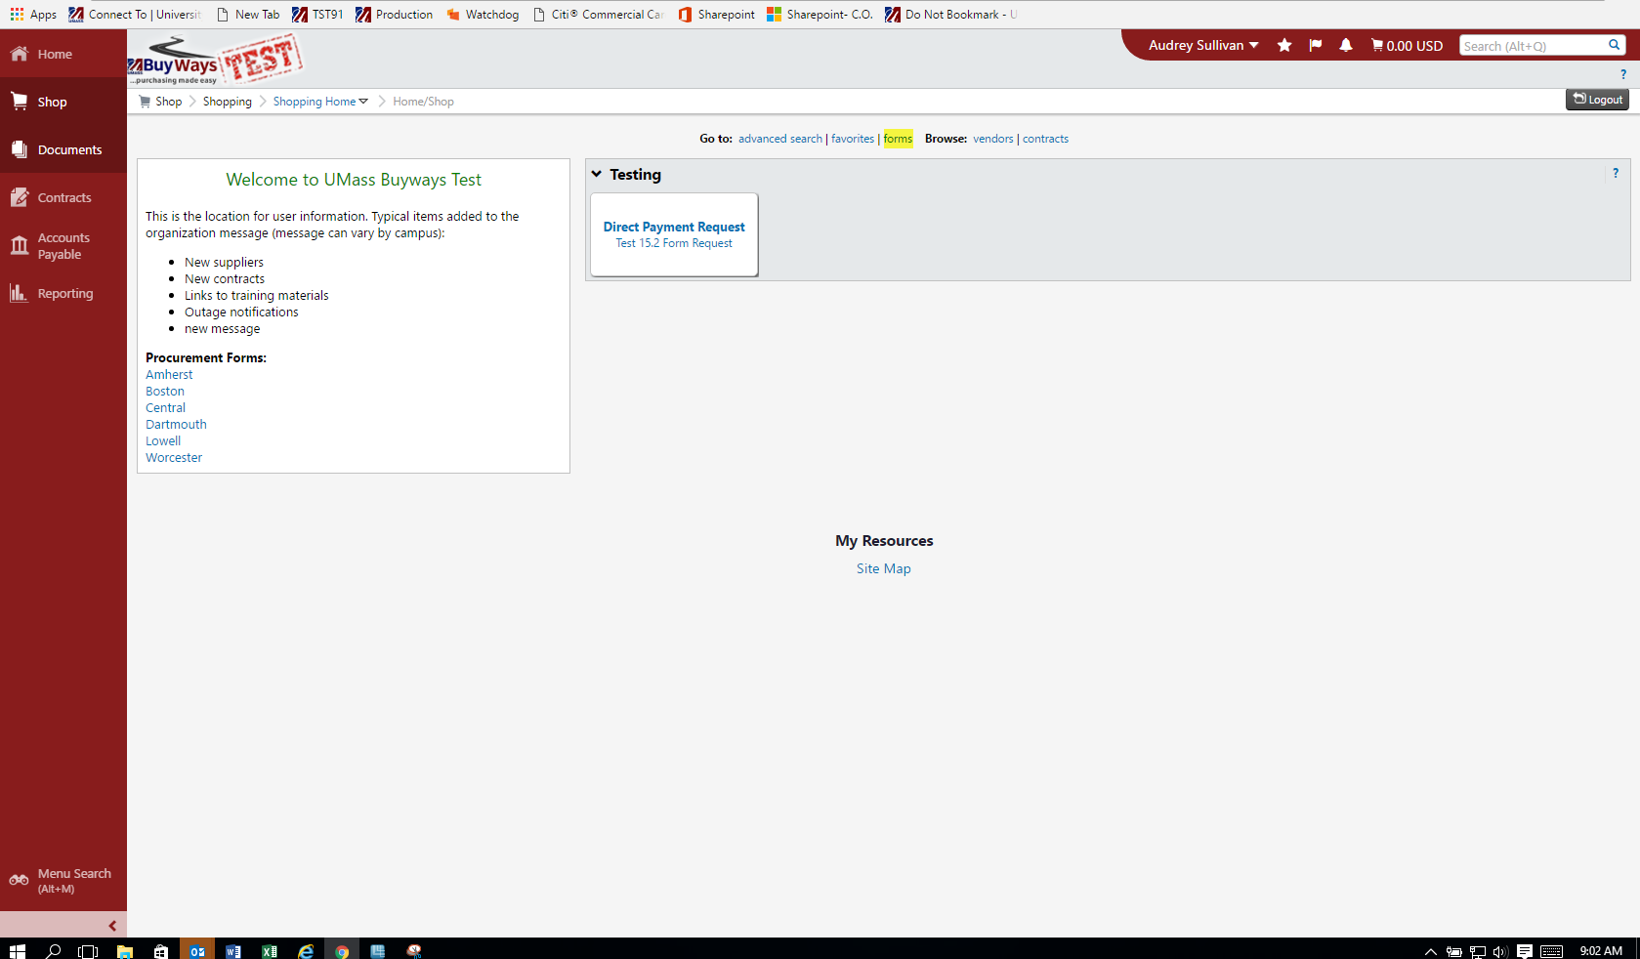

- Complete the following required fields in the Header Section of the ProCard Form:

- Cardholder: Full name of the ProCard account holder
- Last four digits of Card Number: Last four digits of ProCard account number
- Bank Statement Date: Bank statement cycle close date (i.e. 11-15-16)
- Speedtype: Enter department speedtype. *Please note that this field is not used for accounting purposes but needs to be completed only as a BuyWays system requirement.
- Commodity Code: From drop down menu choose ‘UMCEN ProCard Transaction’

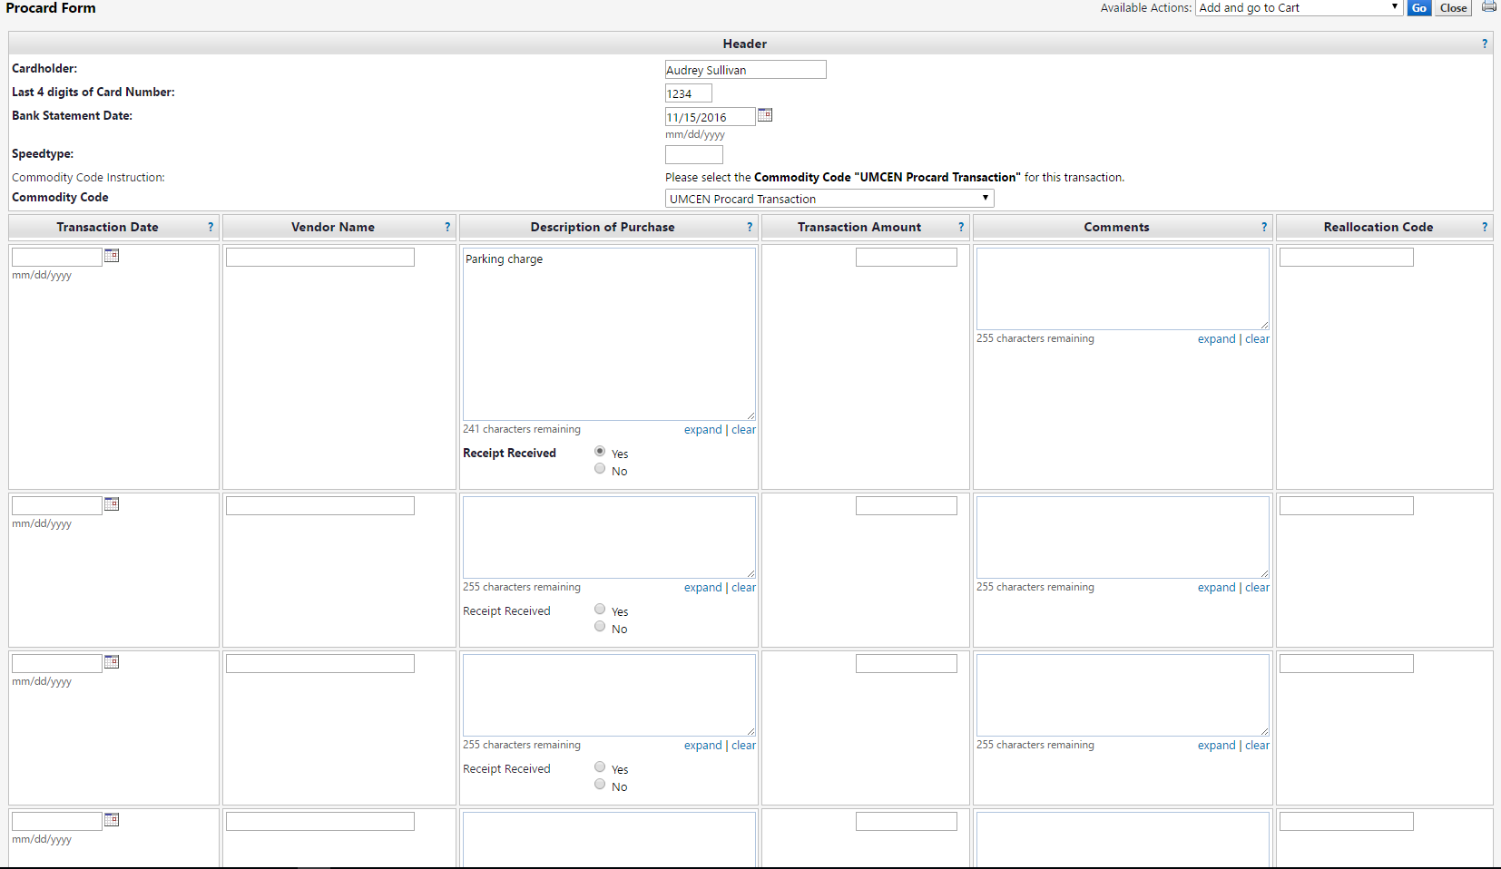

- Complete the following required fields in the transaction line section of the form:

- Transaction Date
- Vendor Name
- Description of Purchase
- Receipt Received- Click ‘Yes’ or ‘No’ radio button (if ‘No’ is clicked, a Missing Receipt Affidavit must be attached- see step 11/pg. 9 below).
- Transaction Amount- Important Note- This field will not accept negative amounts. If the transaction is a credit, enter the dollar amount as zero (0) and make a notation in the Description and Comments field that the transaction is a credit.
- Comments- any additional detail needed for purchase description
- Reallocation Code (non-required field) - for internal departmental use to track speedtype/account information

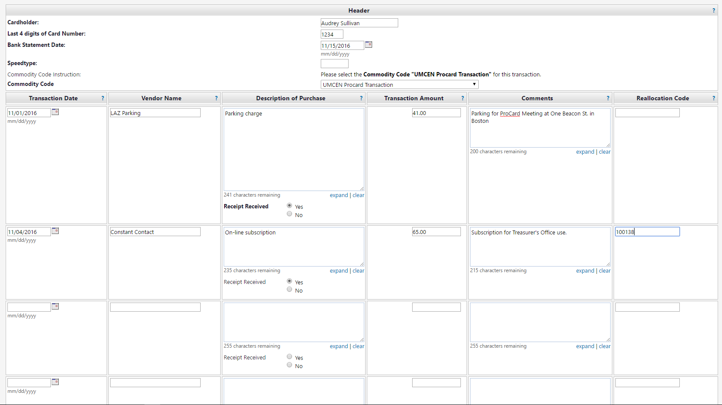

The ProCard Form template contains 15 lines. If additional lines are needed, additional ProCard Forms will need to be completed. From the Available Action drop down menu, choose ‘Add to Cart and Return’. The Form that was just completed will be sent to your Cart and a new blank form will take its place.

- When all transaction lines have been completed, go to Available Actions and choose ‘Add and Go To Cart’ from drop down menu.

- The ProCard Form(s) that have been created and sent to the Shopping Cart will be staged in the Shopping Cart page.

Note-
If required fields have not been completed, it will be flagged with an error message.
Click on the blue ‘ProCard form’ link contained within the Alert message to return to
the Form.

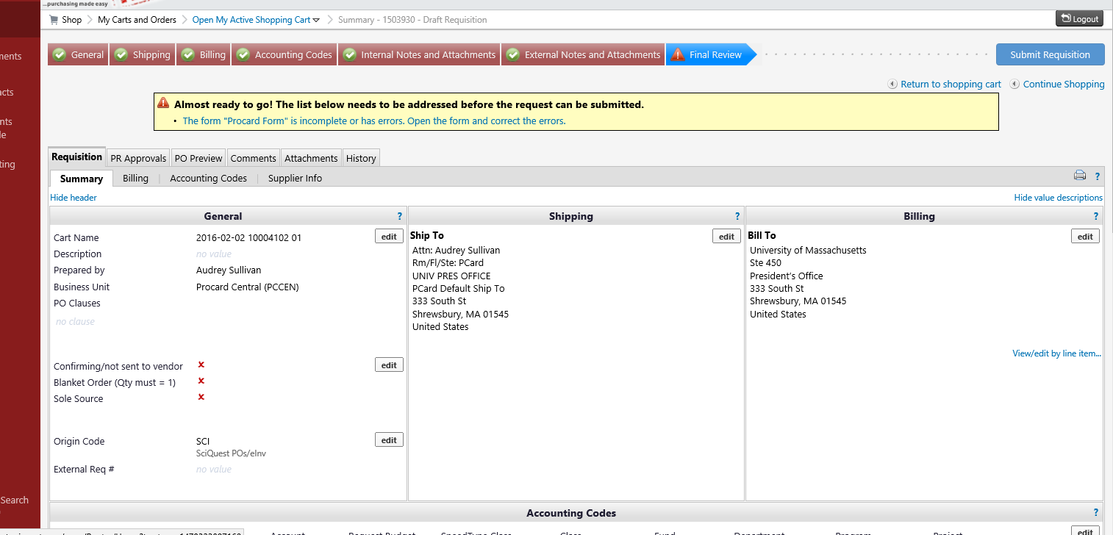

- The fields requiring completion will be highlighted within the form.

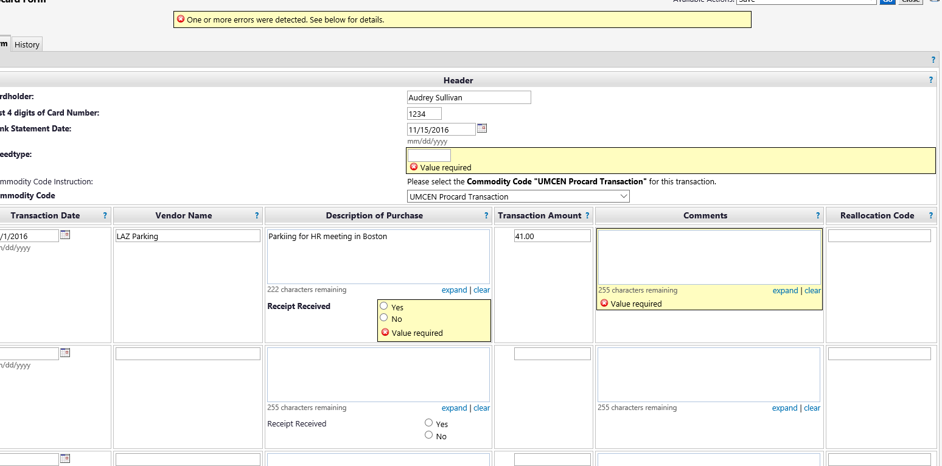

- Once all required fields have been completed, choose Save from the drop-down menu and click Go. This action will return the ProCard Form to the Shopping Cart in its updated status.
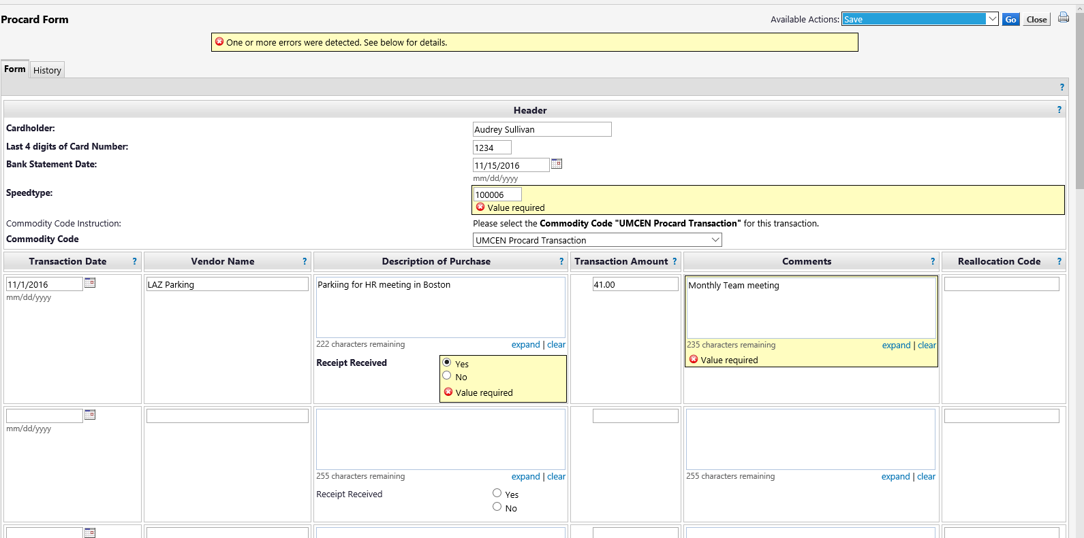

- If the Form needs to be deleted at this point, click the checkbox next to the transaction total and then click the arrow for the dropdown menu in the ‘perform an action field’. Click on the ‘Remove Selected Item’ link. Form will then be deleted from Cart.

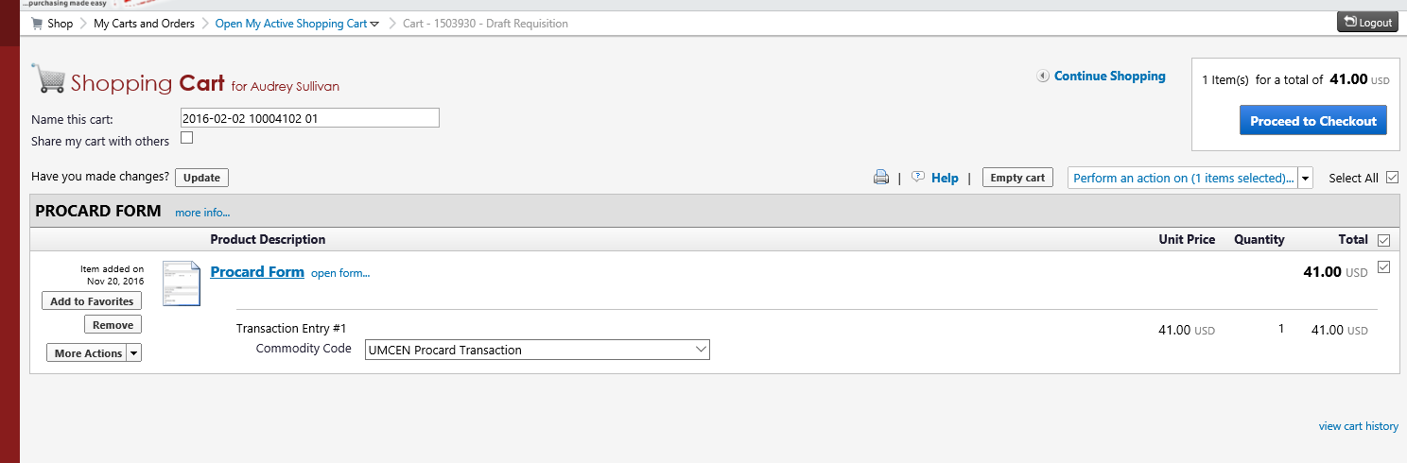

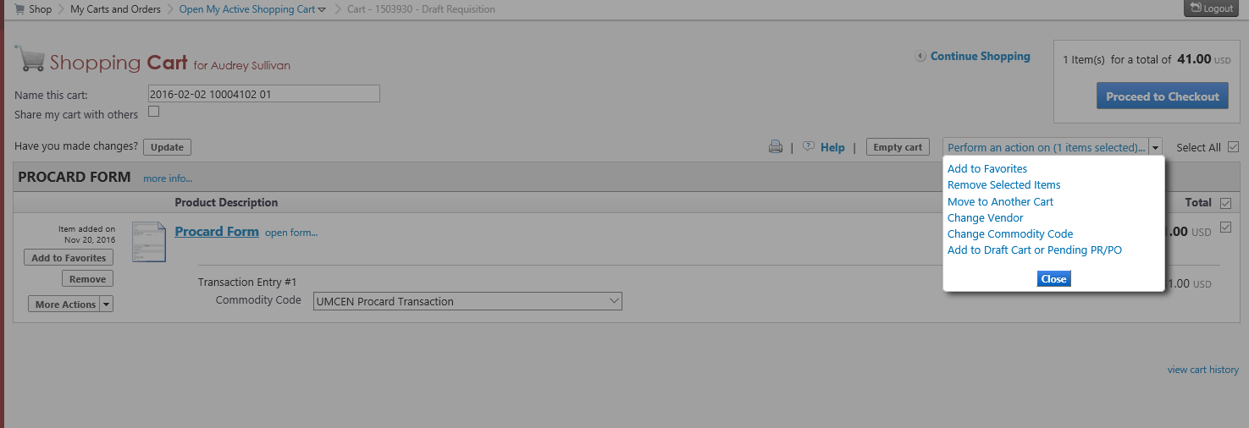

- In the ‘Name this Cart’ field, enter the cardholder name and statement date (i.e. ‘Audrey Sullivan Statement 4-15-17). This Cart Name will act as a cross- identifier for the requisition number that will be created once the ProCard Form is submitted.
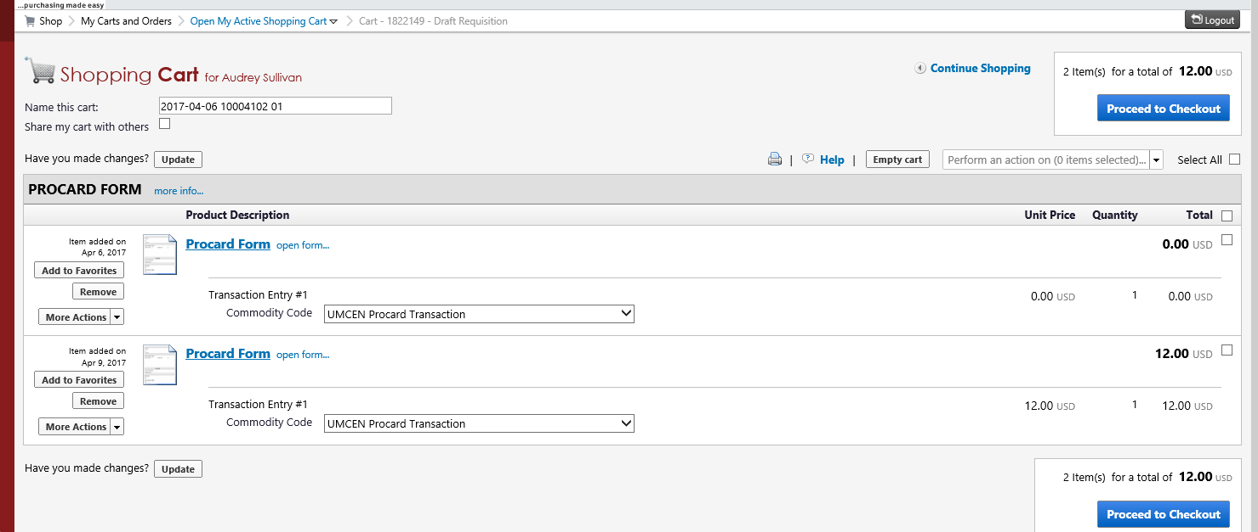

- Once Form is completed and is ready to be moved out of the Shopping Cart to the next step in workflow, click ‘Proceed to Checkout’
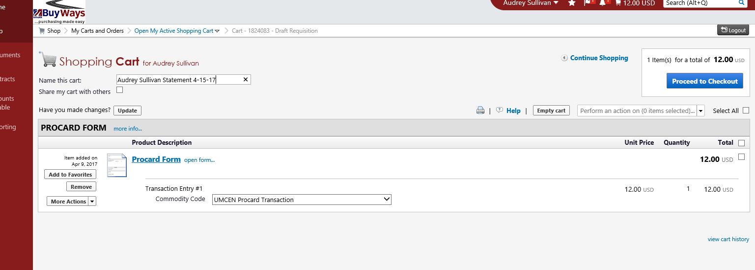

- The staged Form from the Cart will now become a draft requisition in the Final Review step.

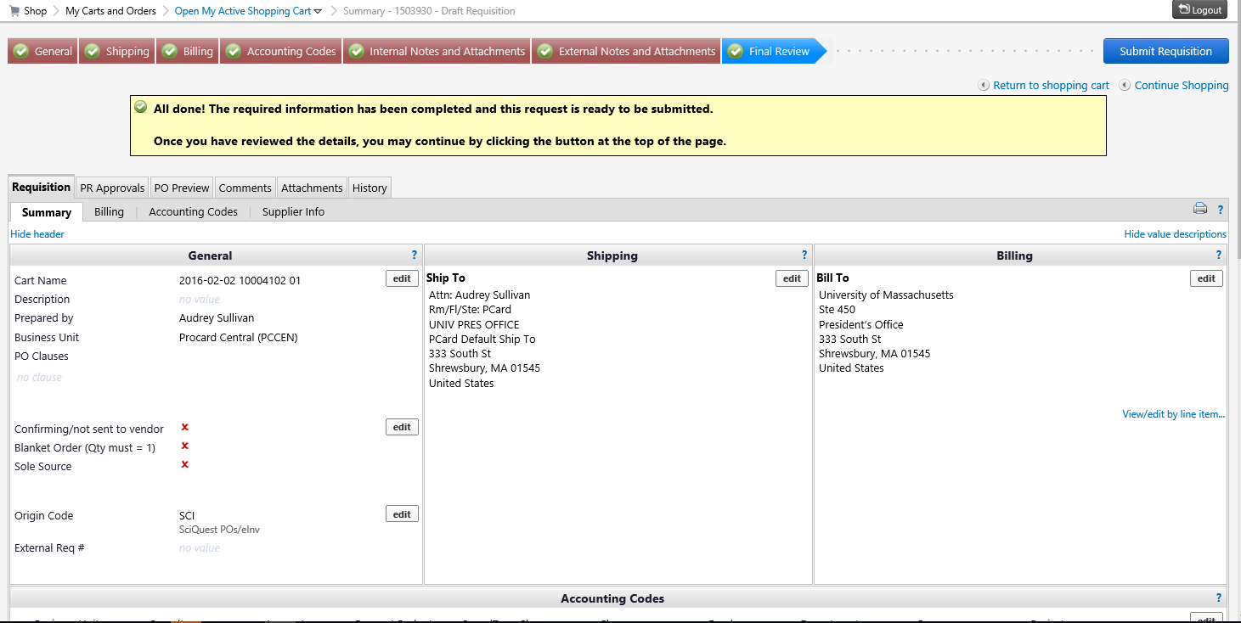

- Go to the ‘Internal Notes and Attachments’ section at the middle of the
page and click ‘Add Attachment’ to add required backup documentation (statement,
receipts, etc.). A pop-up window will appear.

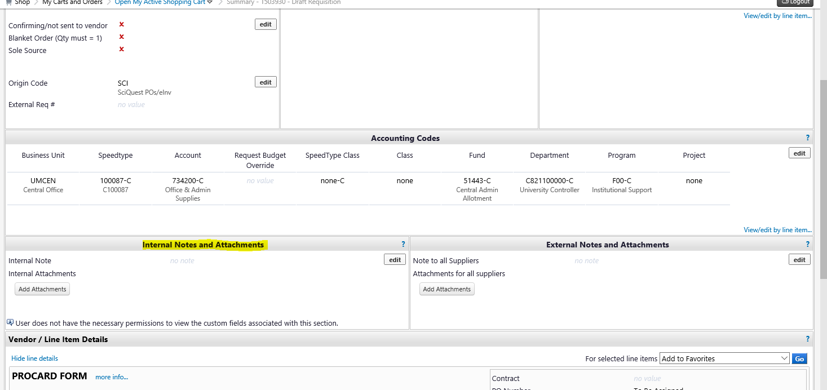
Important- the top line of the Citibank statement must be blocked out of
PDF document before it is uploaded as an Attachment to the Req. (shown below).
The full ProCard account number should also be blocked out on any other backup
documents (receipts, e-mails etc.).

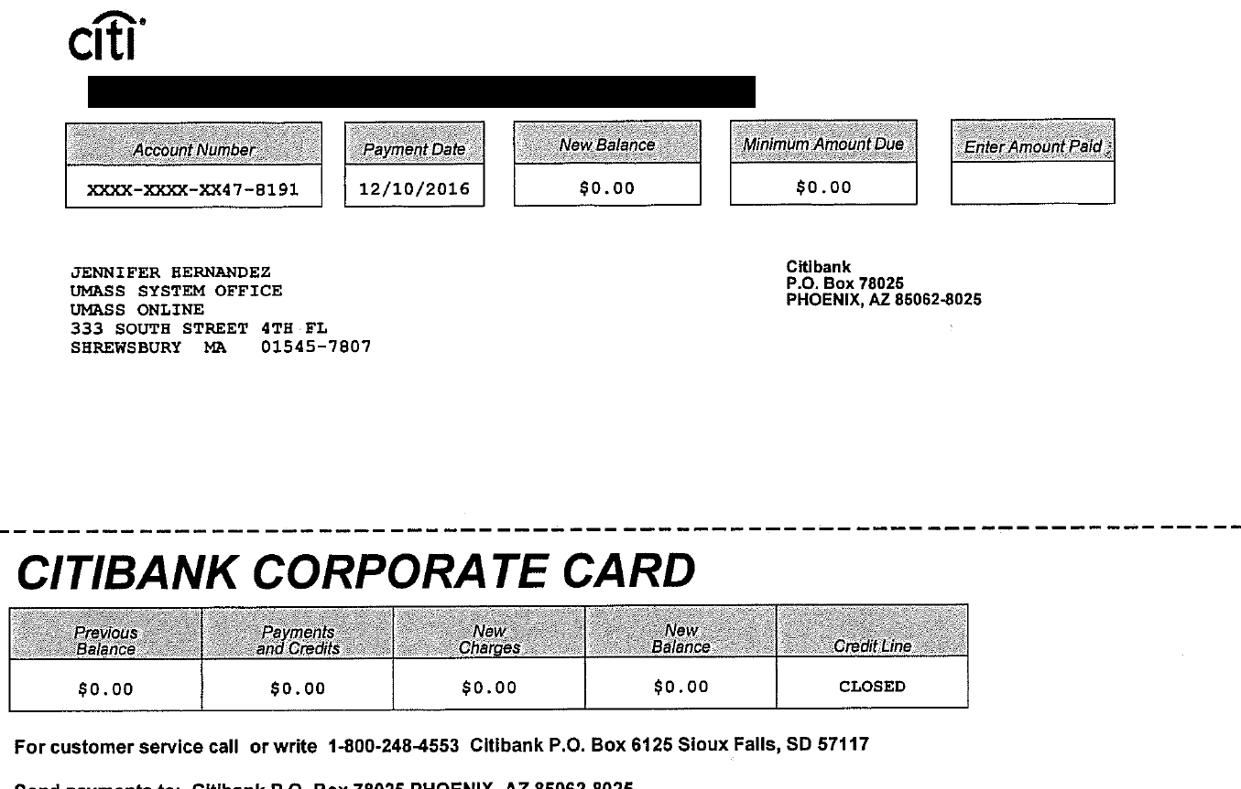

- Click ‘Select File’ and upload the PDF file(s) containing the
statement, receipts and any other backup documentation.

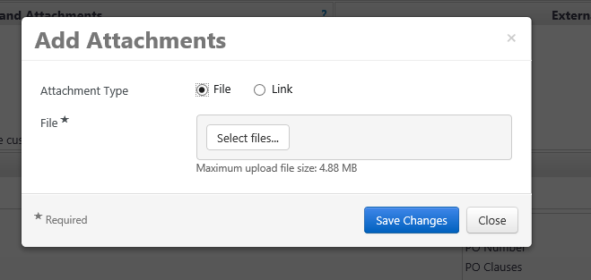

- Click ‘Save Changes’.

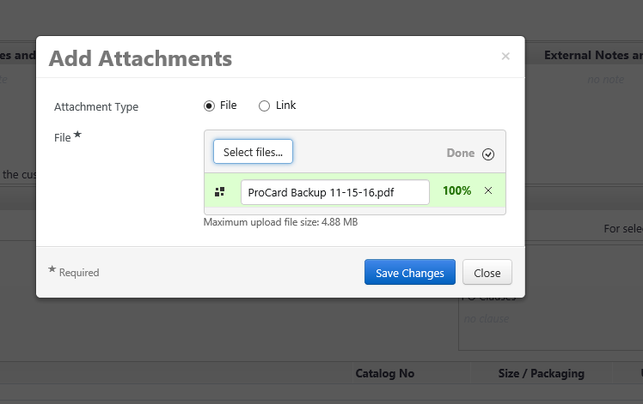

- Optional notes can be added to the draft req. by clicking the ‘edit’ in the Internal Notes
and Attachments section.

- A pop-up window will appear with a field to enter notes. Once entered, click Save.
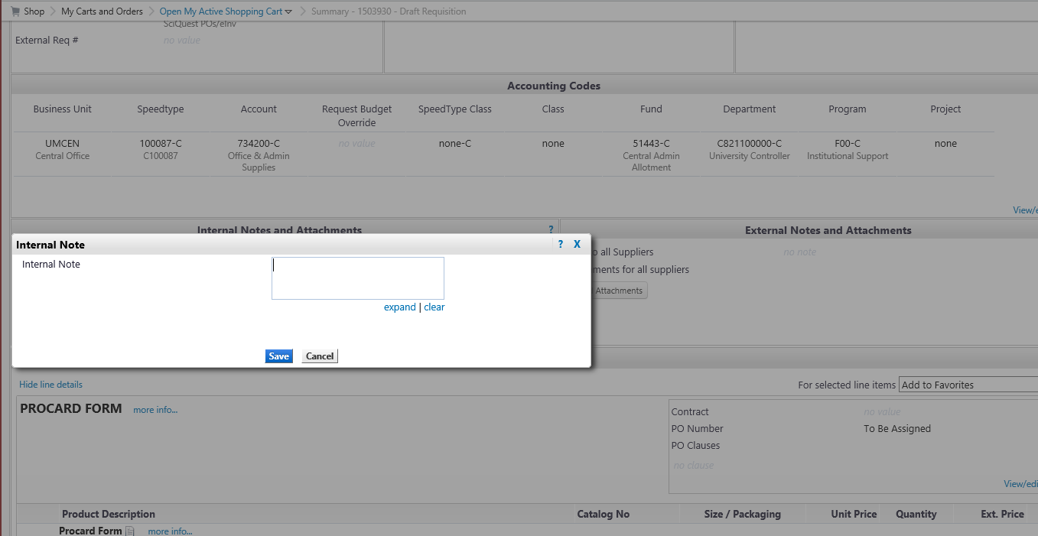

- Once attachments have been uploaded and all required fields have been
completed, the requisition can be submitted for approval.

- If you are a user who creates ProCard Forms for only yourself or one cardholder, skip to Step 15 to submit the req.

- If you are a user who creates ProCard Forms for more than one cardholder, follow steps a. through e. below before submitting the req. so the ProCard Form/Requisition will be routed to the correct cardholder and their manager for approval:

- In the Summary tab of the Requisition, click on the edit link in the above the ‘External Req. #’ field
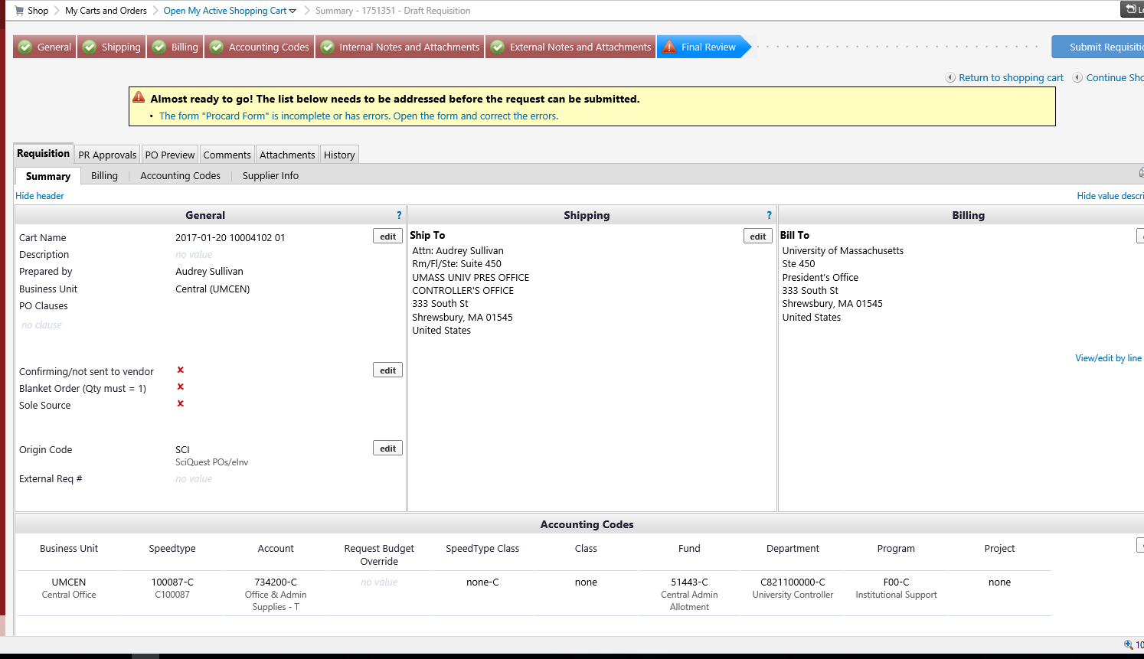

- In the External Requisition Details pop up window, click ‘Select from profile values’

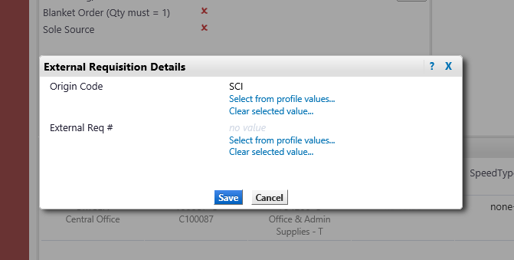

- Click on the dropdown menu to display the list of Cardholders
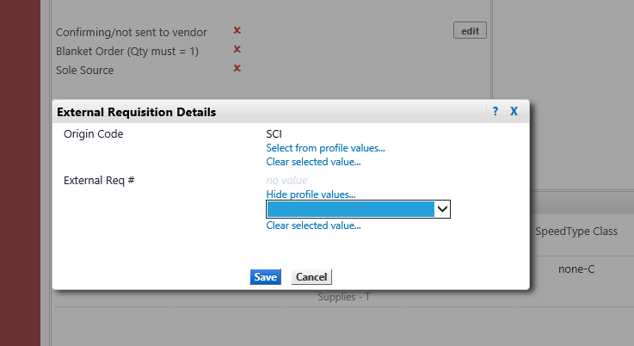

- Select the name of the applicable Cardholder and then click ‘Save’.

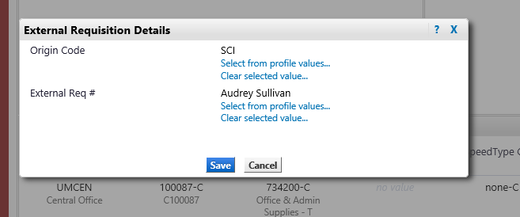

- The name of the cardholder that the ProCard Form will be routed to will for approval will then be displayed in the External Req. # field.

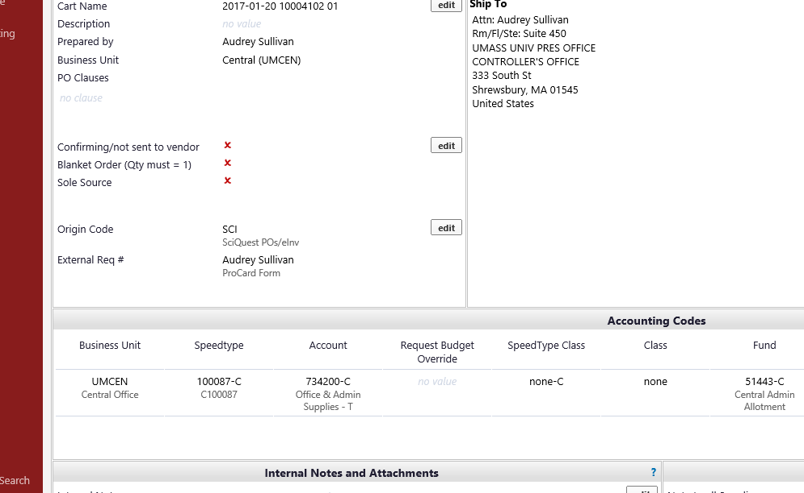

- When ready to submit the req. for approval, click ‘Submit Requisition’

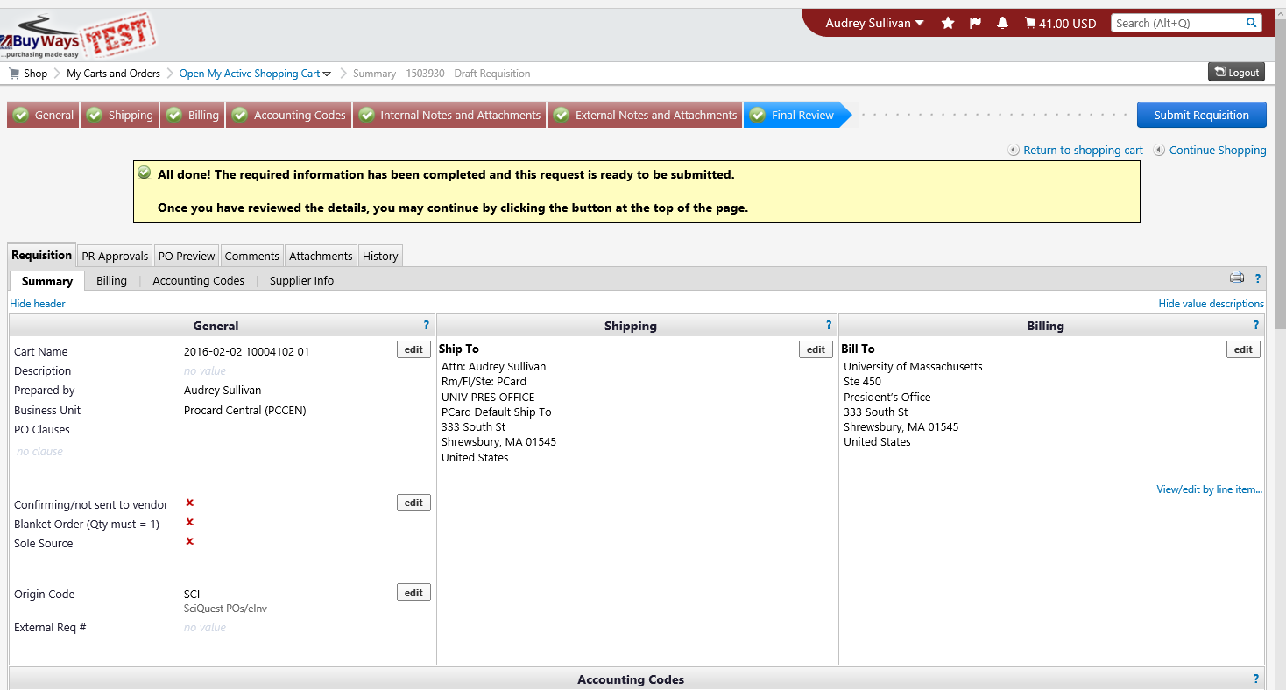

- A submission confirmation will be displayed. The ProCard requisition will then move on
to the next designated approver in the departmental workflow which will be the
Cardholder approval.

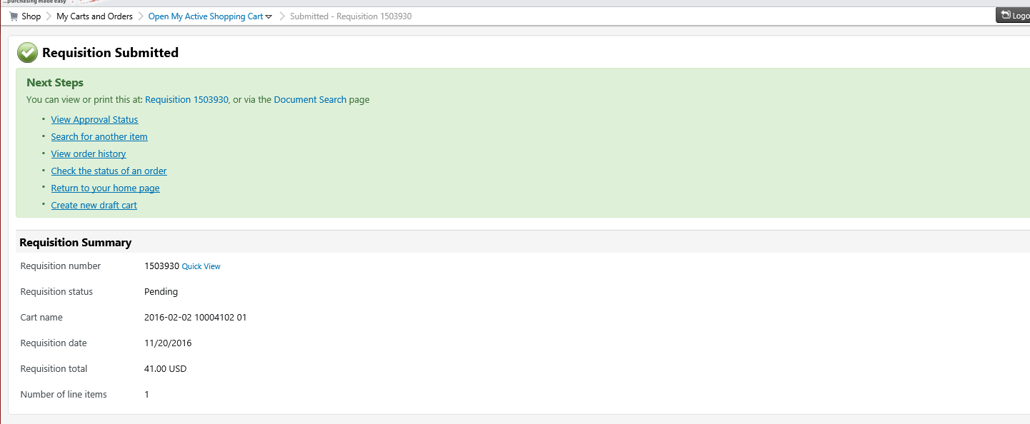

Revising a returned requisition

- If a ProCard requisition is returned for revision, the designated creator will receive a Sciquest system generated e-mail which will notify that a requisition is pending revision. A read-only version can be viewed by clicking on ‘View Requisition’ within the confirmation. To edit the req., the creator must log into BuyWays.

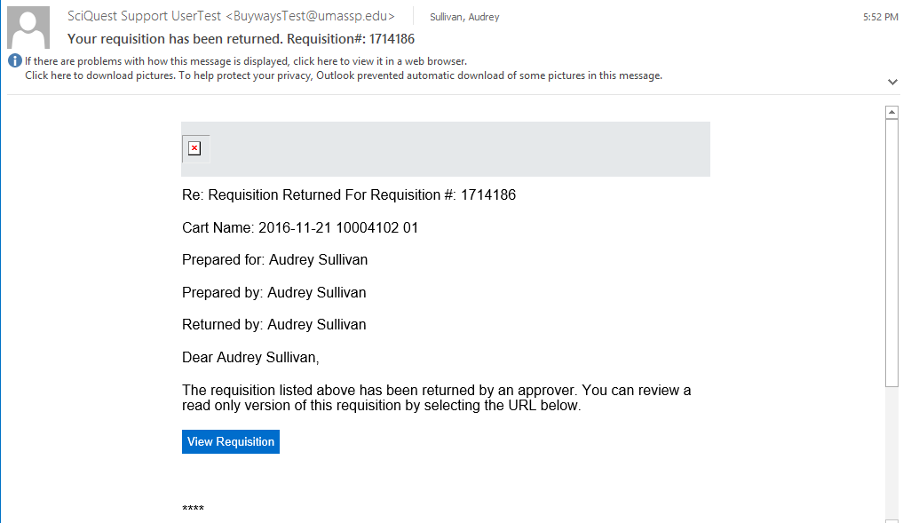

- Once logged into the BuyWays ‘Shop’ page, click on the notification flag. Then click on ‘My Returned Requisitions’

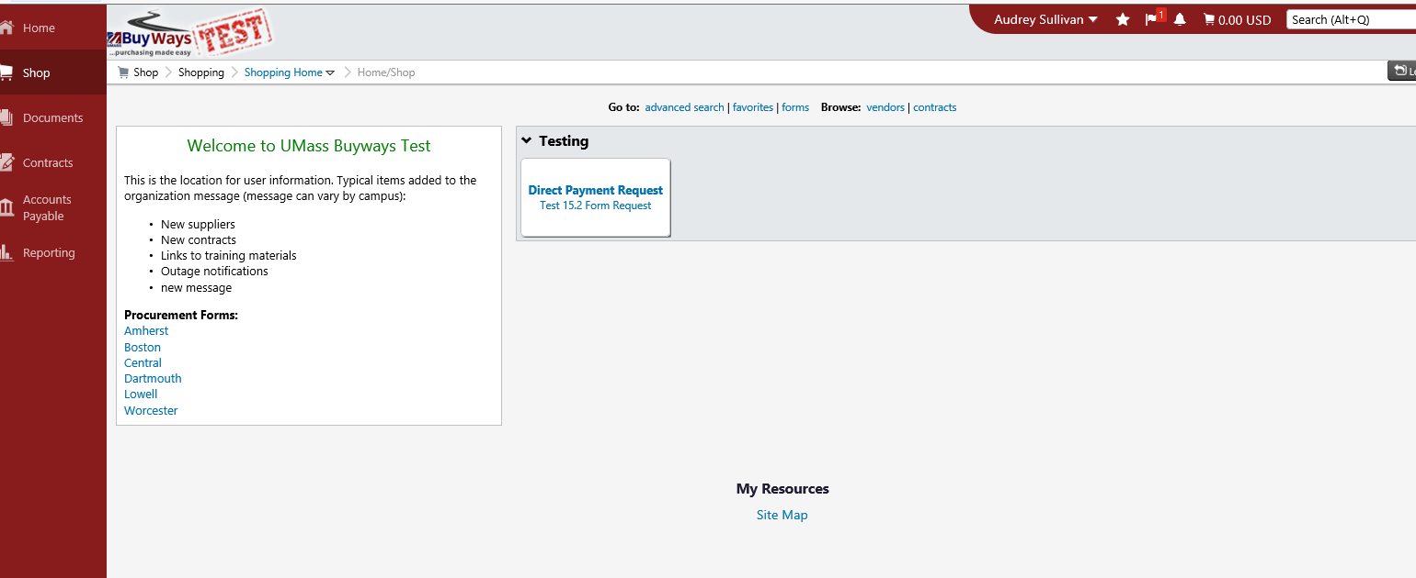

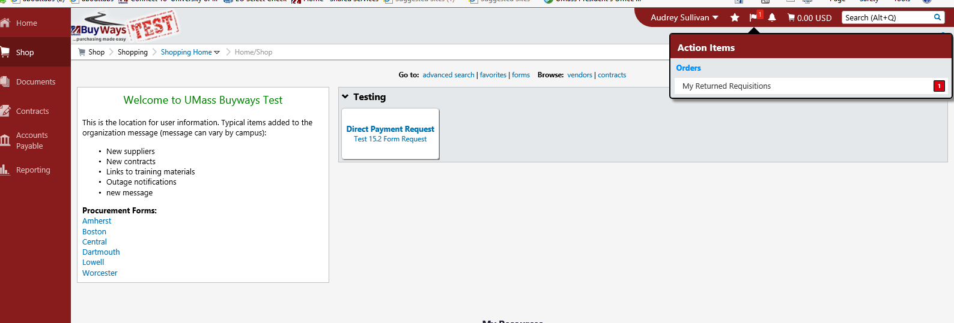

- Click the requisition number to be updated (highlighted in blue text).

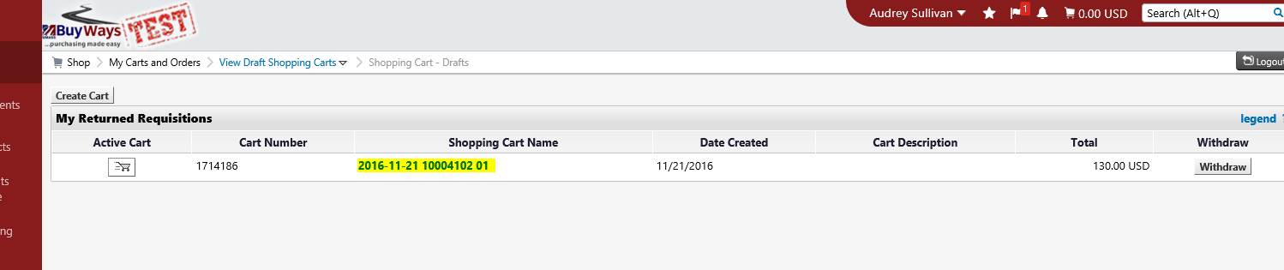

The requisition Summary page will be returned. Please note, BuyWays will display a message stating that the required information is complete and ready for submission. This refers to the information that BuyWays requires from a system standpoint only.
- To view the additional information/update that is needed from the approver who returned the req., click the ‘Comments’ tab.

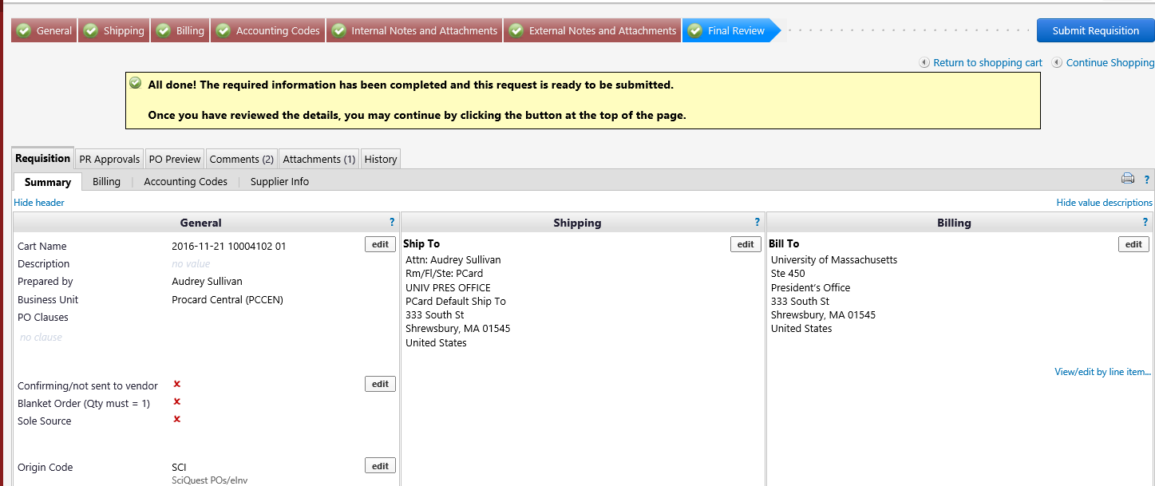

The approver’s Comments will be displayed.

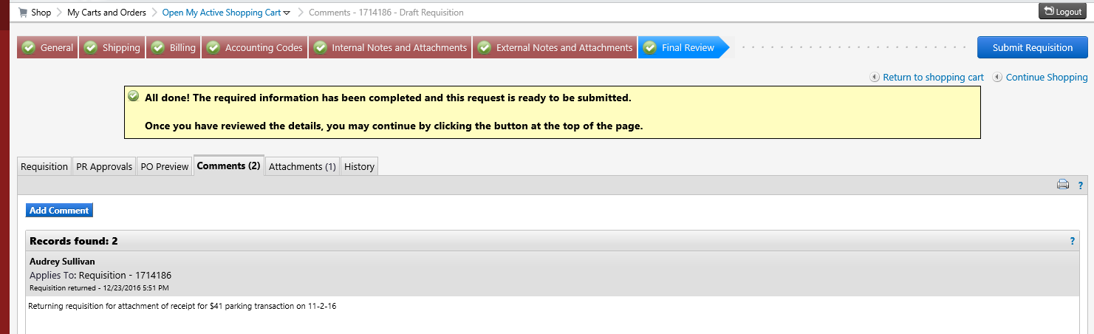

- Once all updates/revisions have been completed, click ‘Submit Requisition’ to resubmit the requisition through approval workflow. A submission confirmation message will be returned. Once resubmitted the requisition will once again need to go through all levels of workflow approval (as designed by department).

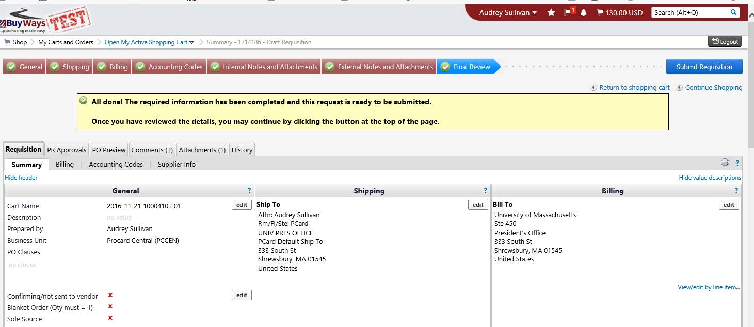

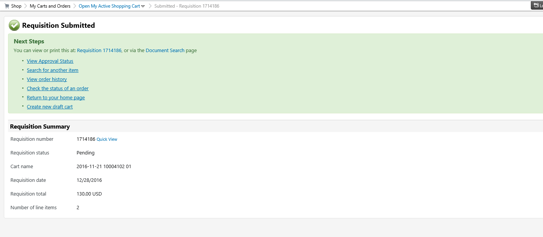

Reviewing an electronic ProCard reconciliation for approval

- When a ProCard requisition is submitted for approval, the approver will receive a BuyWays system generated e-mail from the address ‘Buyways@umassp.edu’ which will notify that a requisition is pending their approval.

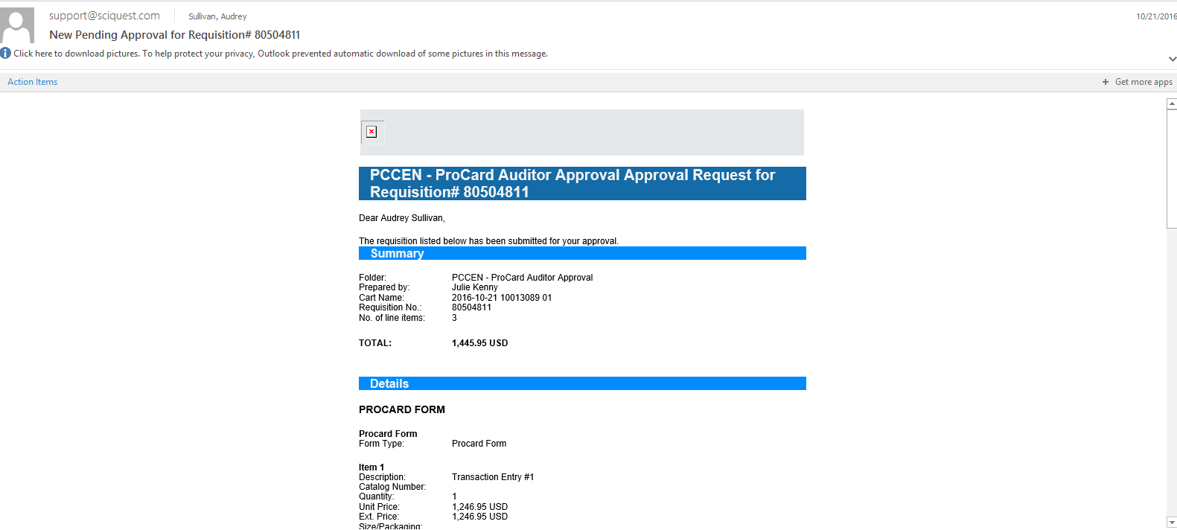

- The requisition can be reviewed and approved in BuyWays by clicking the ‘View Requisition Approvals’ link at the bottom of the e-mail. The req. can also be reviewed and approved by logging directly into BuyWays independent of the notification e-mail. Please note

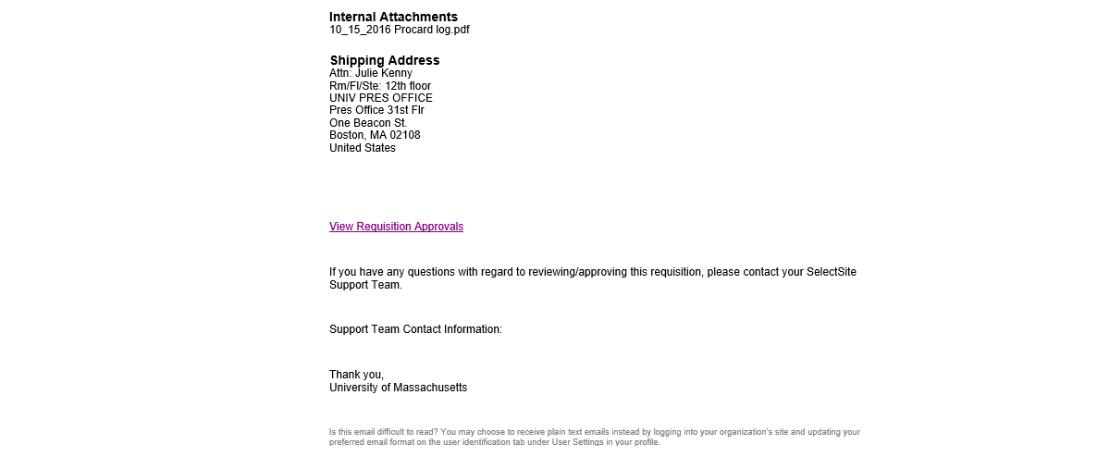
Important- Approval of the requisition cannot be done by clicking the ‘Take Action’ button in the body of this e-mail. Per ProCard policy, The ProCard Transaction Log (ProCard Form) and all accompanying attachments must be reviewed and cannot be accessed from this link. The Cardholder must log in to BuyWays to review and approve the requisition and attachments

- Once logged into BuyWays, the pending requisition(s) will be flagged as an
Action Item and a Notification in your dashboard.

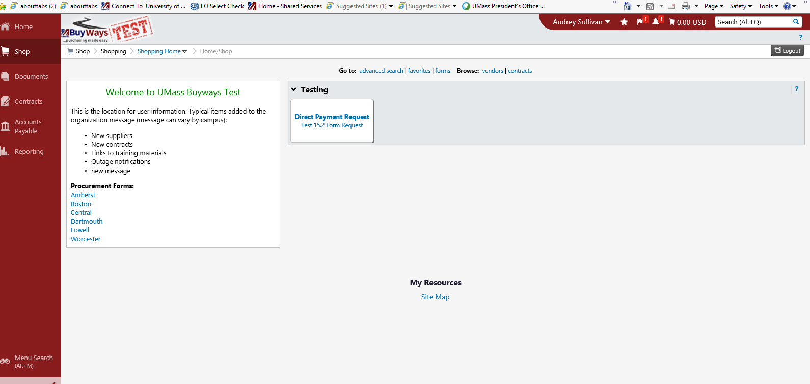

- To access the requisition, click on the ‘Action Items’ icon and then click Requisitions.

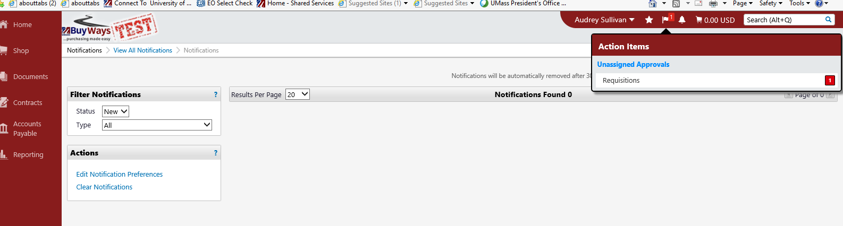

- In this Documents page click the requisition number to be approved (highlighted in blue).
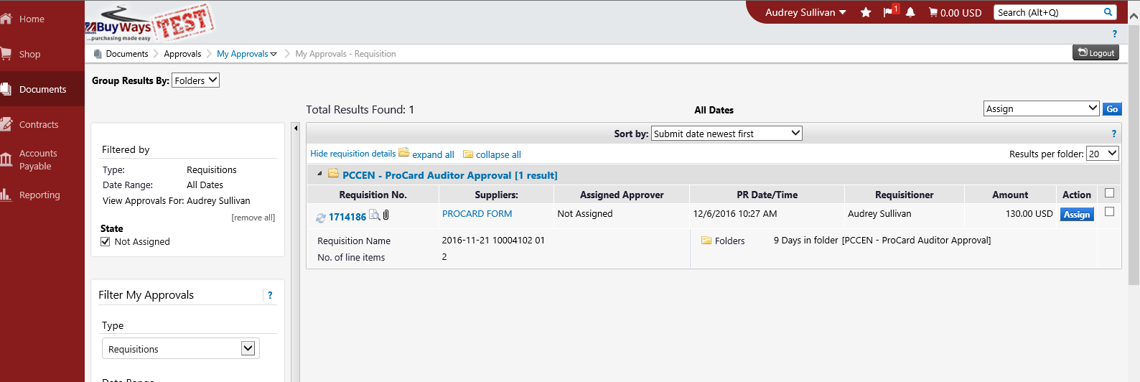

- The Requisition Summary page will be displayed. This page displays an overhead summarization of the requisition.

Important- Per ProCard policy, approval is not considered valid if review of the req. consists solely from the information provided on this page. The ProCard Transaction Log (ProCard Form) and all accompanying attachments must be reviewed. See the following steps to access these documents.

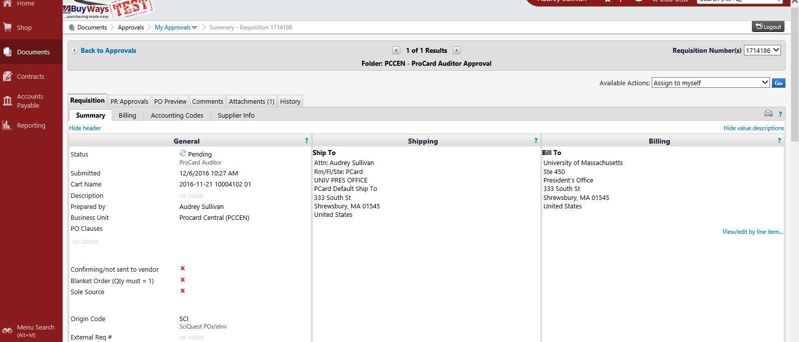

- To access the ProCard Transaction Log scroll down the page to the ProCard Form section and click on the ‘ProCard Form’ link highlighted in blue.

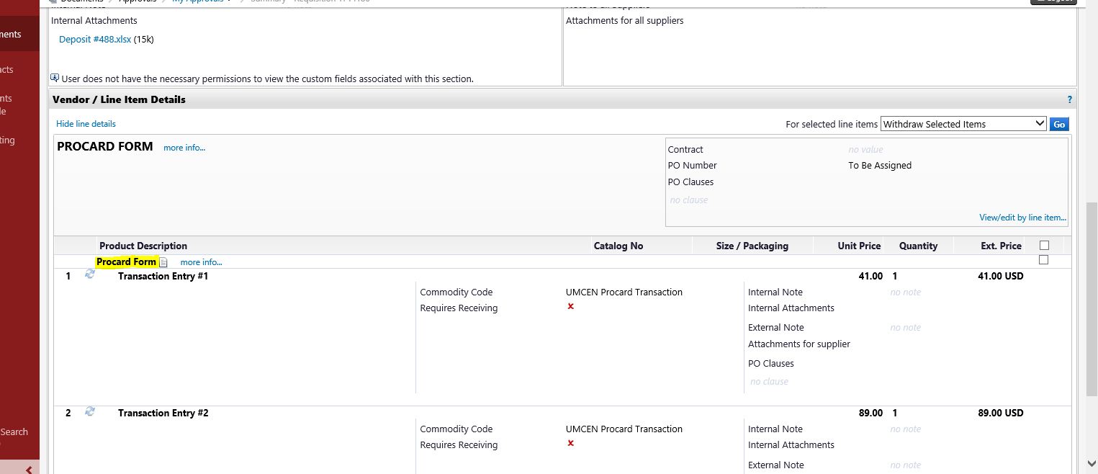

- The transaction log will be returned. All of the information included on the ProCard Transaction Log must be reviewed against the Citibank statement and receipts (attachments). Please note that the speedtype field is not used for accounting purposes but is completed only as a BuyWays system requirement.
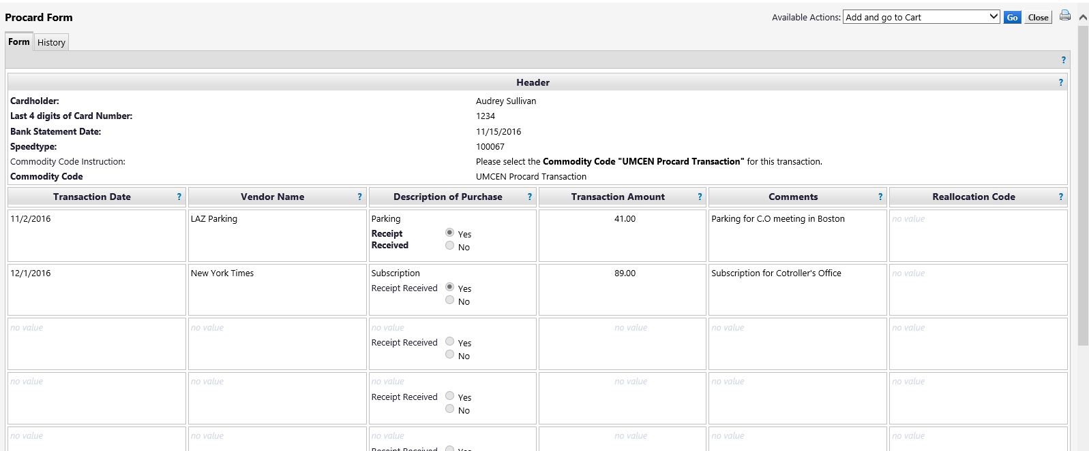

Important- The Cardholder Certification statement is located at the bottom of the Transaction Log. A ‘wet’ signature on the transaction log is no longer required when a ProCard reconciliation is processed electronically through BuyWays. By electronically approving the Requisition in the Cardholder workflow step, the Cardholder is certifying that the expenses entered on the Transaction Log are correct and true and were for official University Business. The Supervisor’s and *Fund Administrator’s (*as applicable) electronic approval in the workflow step certifies that they approve the cardholder’s ProCard expense for that statement period.

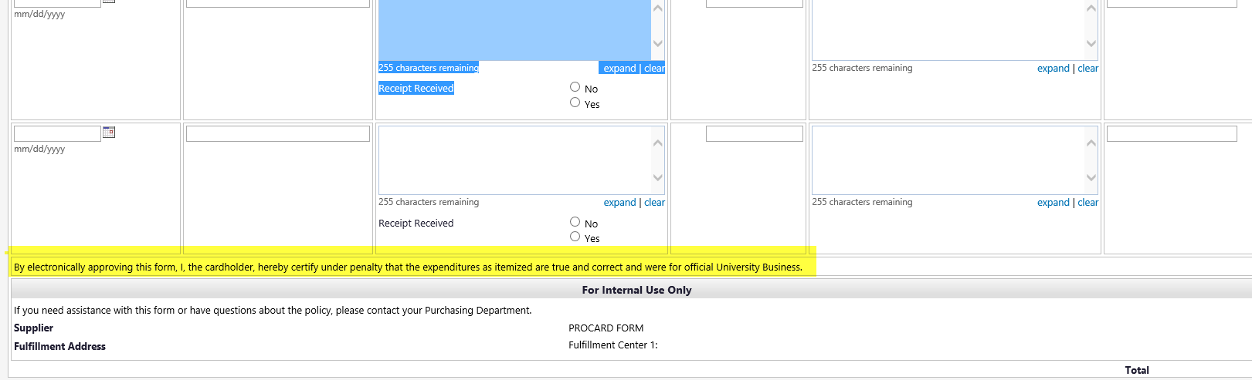

- From the Requisition Summary page, the attachments can be accessed by clicking on the ‘Attachments’ tab at the top of the Summary page or scrolling down to the ‘Internal Notes and Attachments’ section of the page and clicking on the attachment file name (highlighted in blue) under Internal Attachments. Documents included in the attachment(s) must include the Citibank statement, transaction receipts as well as all other additional backup documentation as required per ProCard policy. Once all documents in the attachments have been reviewed in full, the attachment filed(s) can be minimized or closed.

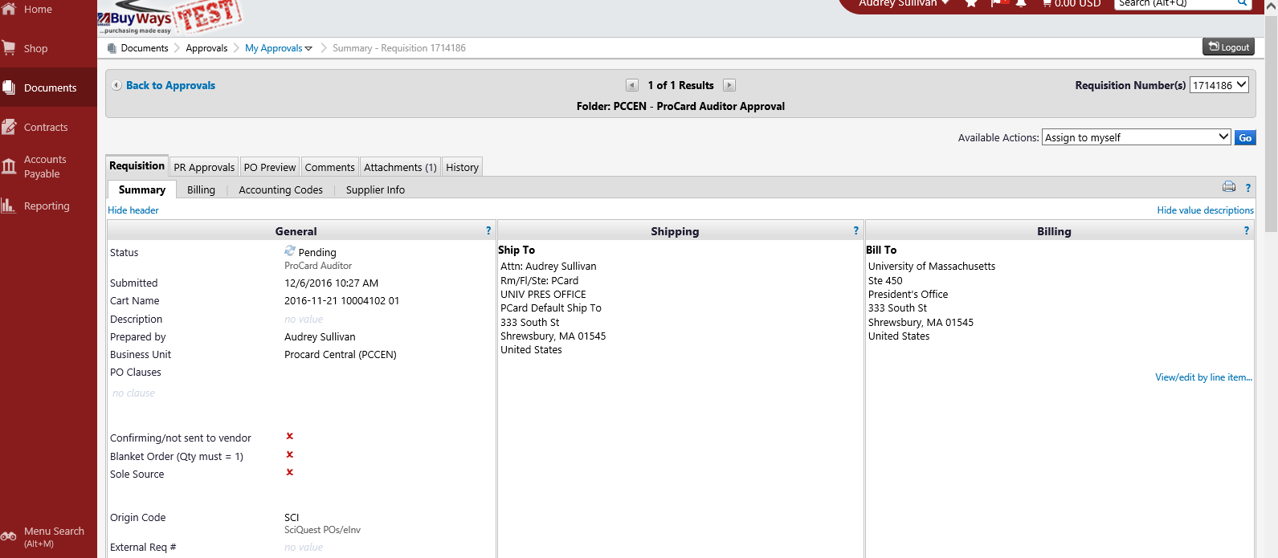

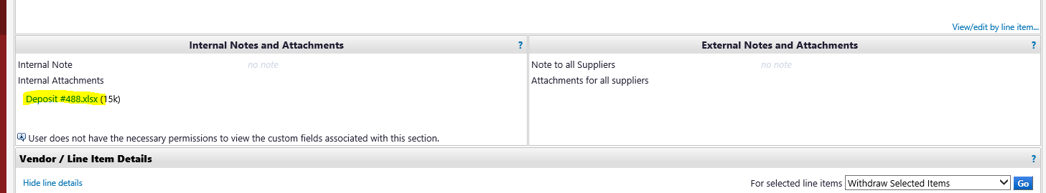

- If the requisition includes Comments, a number will appear by the word ‘Comments’ in the Comments tab at the top of the Requisition Summary page. Click on the tab to view the comments.

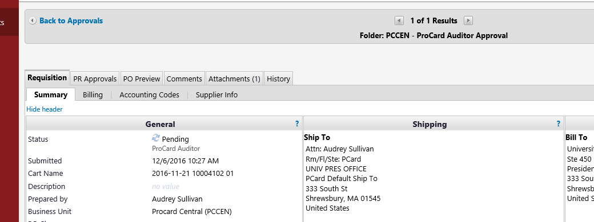

Cardholder comments can also be added to this page by clicking on ‘Add Comment’.

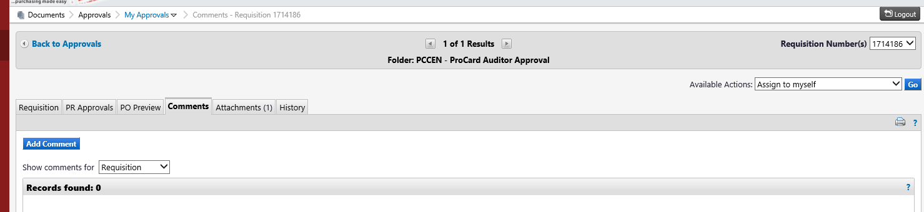

Additionally, the workflow track that the requisition has followed can be viewed by clicking on the ‘History’ tab. The ‘PR Approvals’ tab will display the name of Form Creator and approvers included in the req.’s workflow,

History Tab

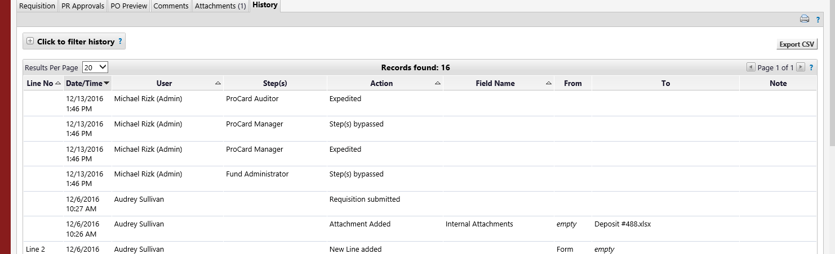

PR Approvals Tab
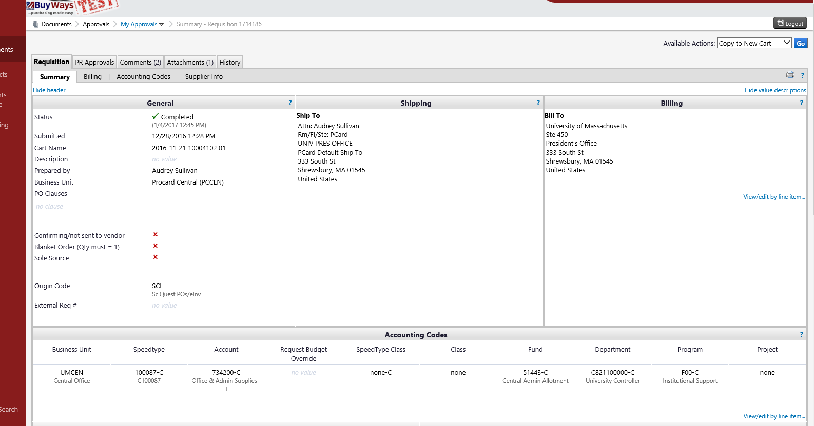

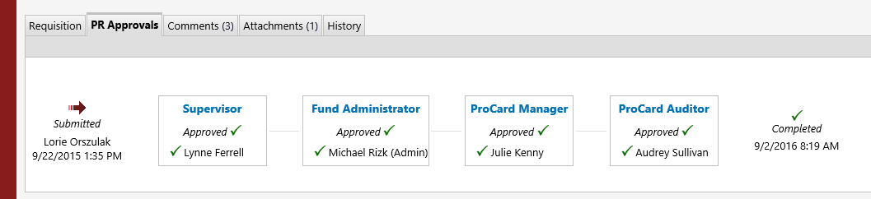

- Upon review of the Transaction Log and attachments, the requisition can either be approved or sent back to the creator for revision. To approve see step 11. To send back for revision, skip to step 16.

Submitting a requisition as approved

- From the Requisition Summary page, click on the drop down menu in the ‘Available Actions’ field and choose ‘Approve/Complete Step’. Then Click ‘Go’.

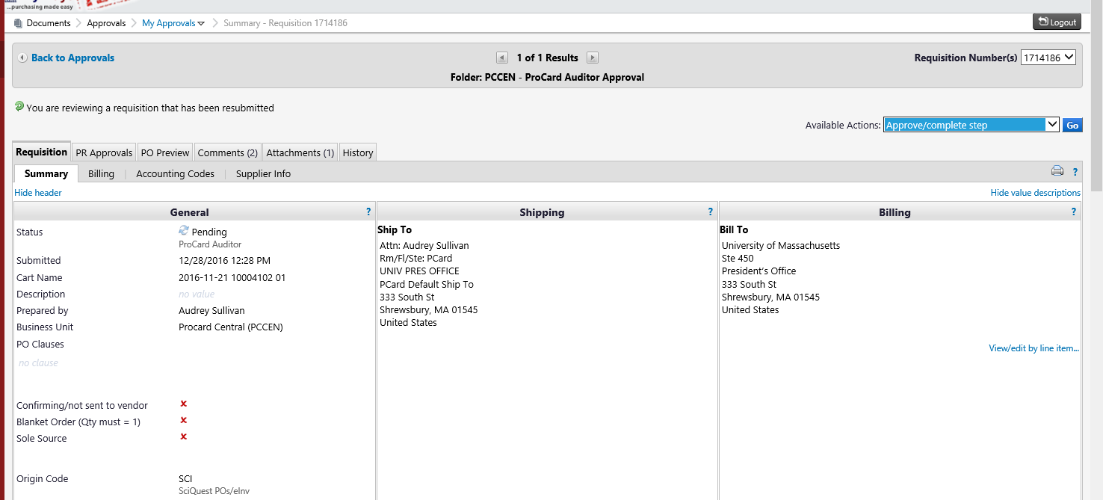

- The navigation will lead to the ‘My Approvals’ page where the Requisition just approved will no longer be present. This signifies that the Requisition has moved to the next step in the approval workflow.

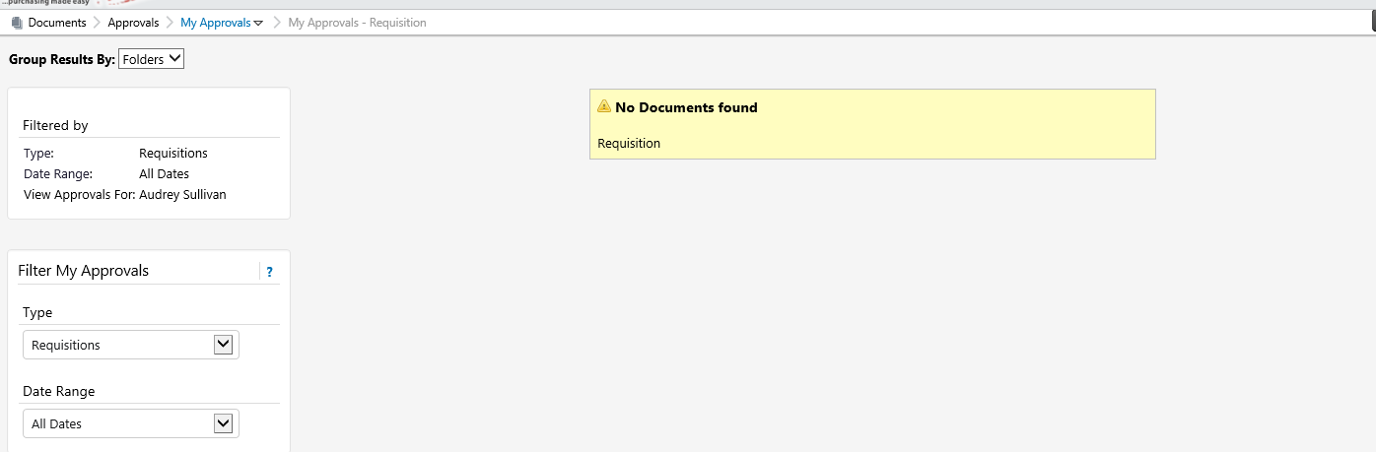

- To confirm the requisition has been moved the next step in the workflow, click on the ‘My Approvals’ hyperlink (highlighted in blue) and then click ‘Recent Approvals’.

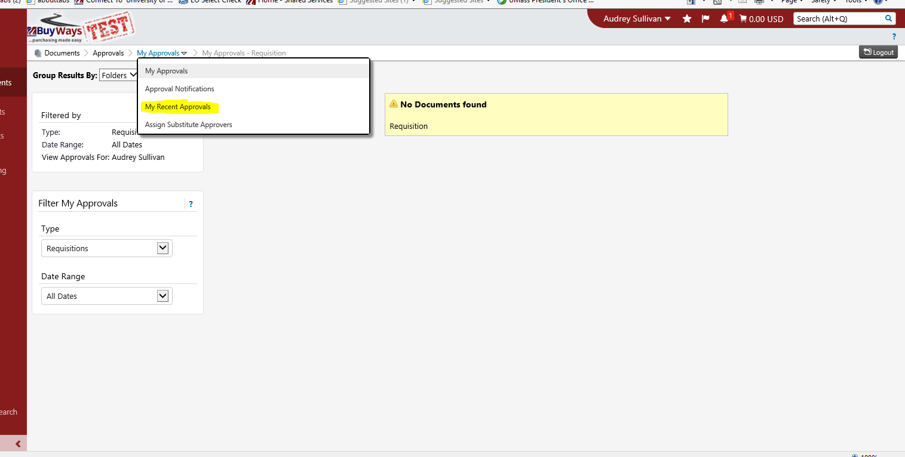

- A listing of recent approval activities will be returned.

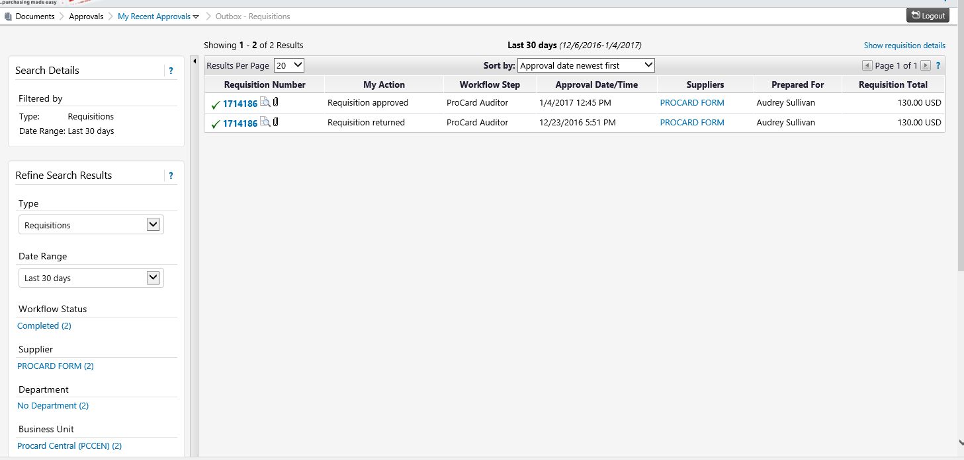

- Document searches can also be conducted by using the filters in the Search Menu on the left hand side of this page.

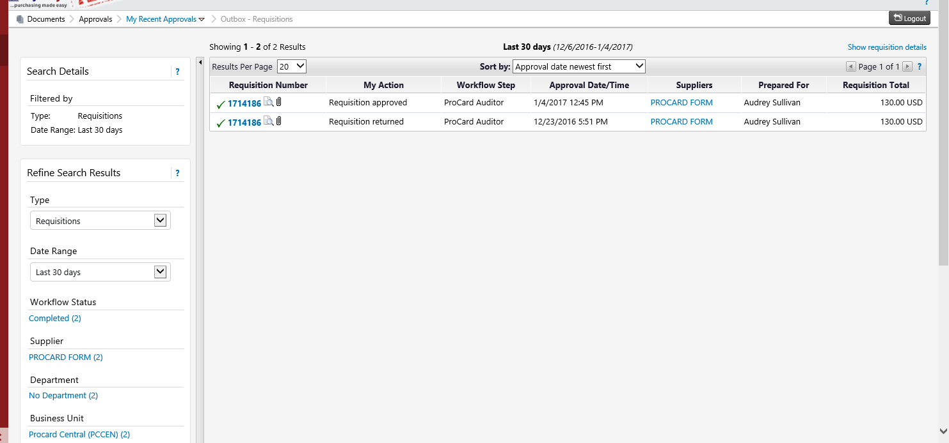

Returning a requisition to the creator for revision

- From the Requisition Summary page, click on ‘Assign to Myself’ in the drop down menu of the Available Actions field.
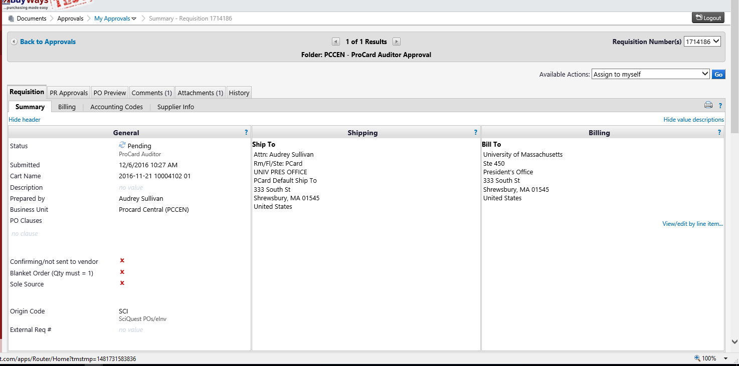

- A dialogue box will appear where the reason for return should be populated. This information will be saved in the requisition History.
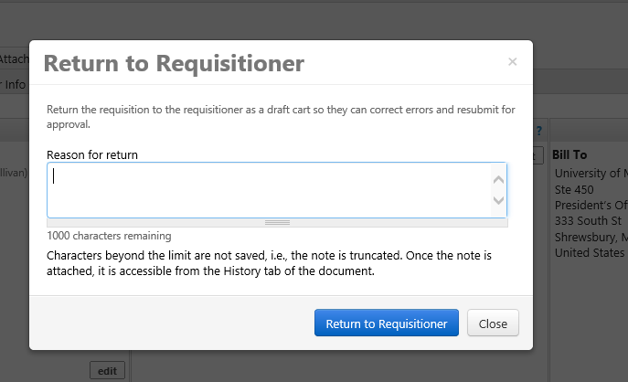

- Once the reason for return has been entered, click the ‘Return to Requisitioner’ button.

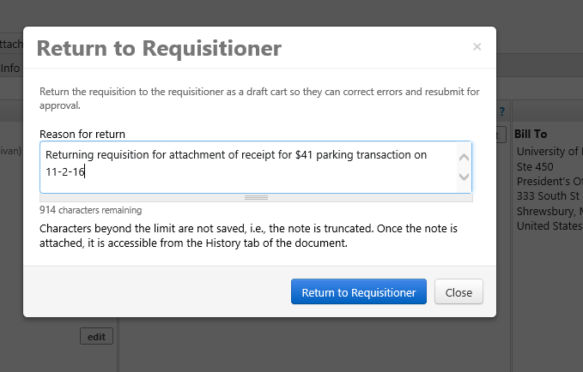

- A systems generated e-mail will be sent to the creator to advise that the requisition has been returned to them. The requisition will be returned to the creator’s BuyWays documents page as a draft where it can be revised and resubmitted. Once resubmitted the requisition will once again need to go through all levels of workflow approval (as designed by department).

Requisition Search

The Document Search feature allows the user to search for requisitions in BuyWays.
- From the Home page, click on the Documents link on the left hand options menu. Then Click ‘Search Documents’.
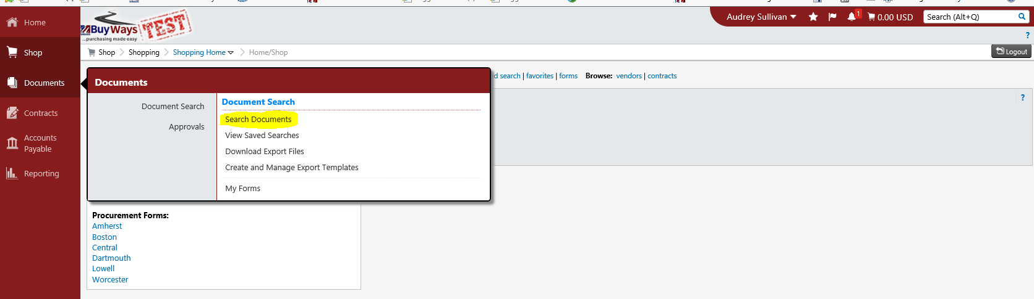

- This navigation will lead to the search page.
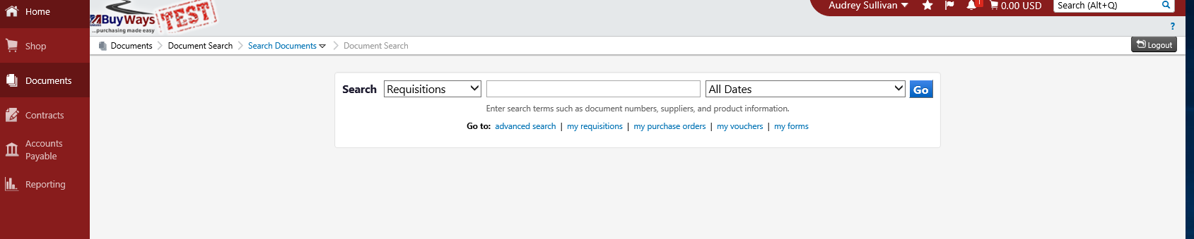

- Enter the applicable criteria into the Search fields (Note- ‘Requisitions’ is the appropriate record type for Procard). If searching for an individual cardholder’s documents, the last name can be entered into the keyword (middle) field. If looking for multiple cardholder records within a date range, leave the keyword field blank. The date range can be chosen by clicking on the drop down menu in the third field. Then click Go.

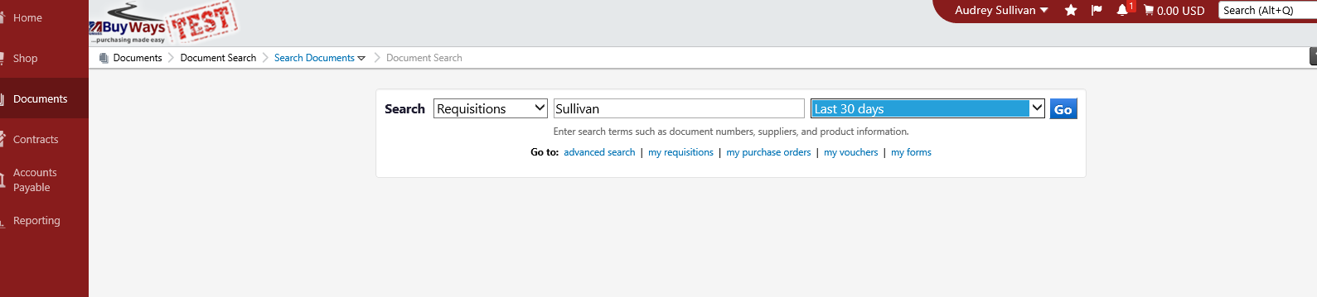

- The search results will be returned based on the criteria entered. To view a Requisition, click on the Requisition Number or Procard Form.

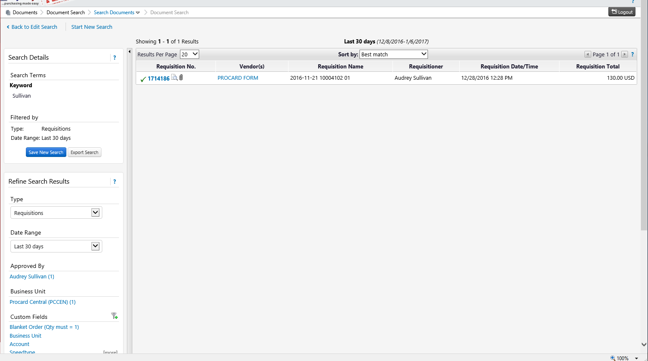

- If desired, the Search Results can be refined using the Search Details menu to the left of the page.

- Search results can be exported to an excel spreadsheet by clicking on ‘Export Search’ in the Search Details menu.

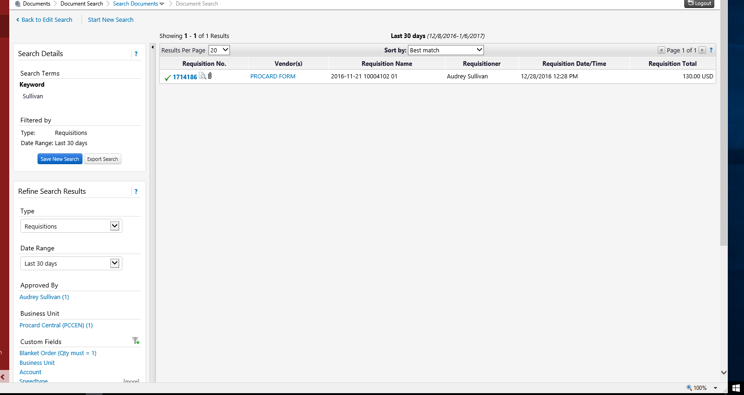

- A screen will appear for entry of the export criteria.

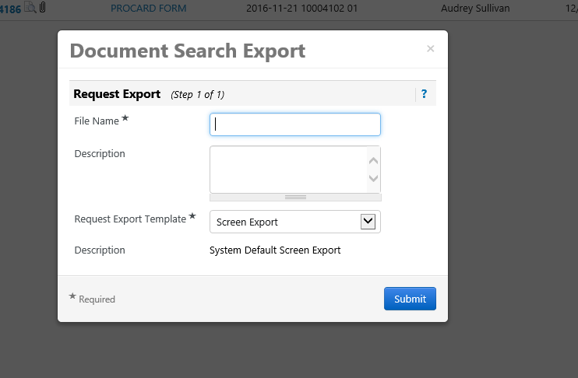

- Enter a file name and description (optional). For a transaction record export, choose ‘Transaction Export’, and then click Submit.

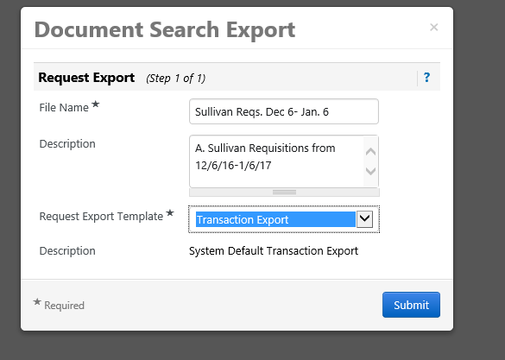

- A dialogue box will appear confirming the success of the export. Click on ‘Go To’ Page: Download Export Files’ to access the export.

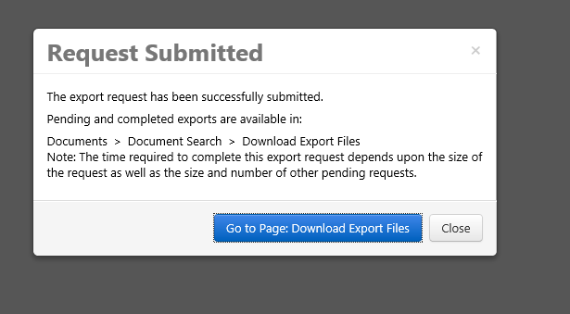

- The navigation will lead to the ‘Download Exports’ tab. From here, click on the zip file for the search results exported.

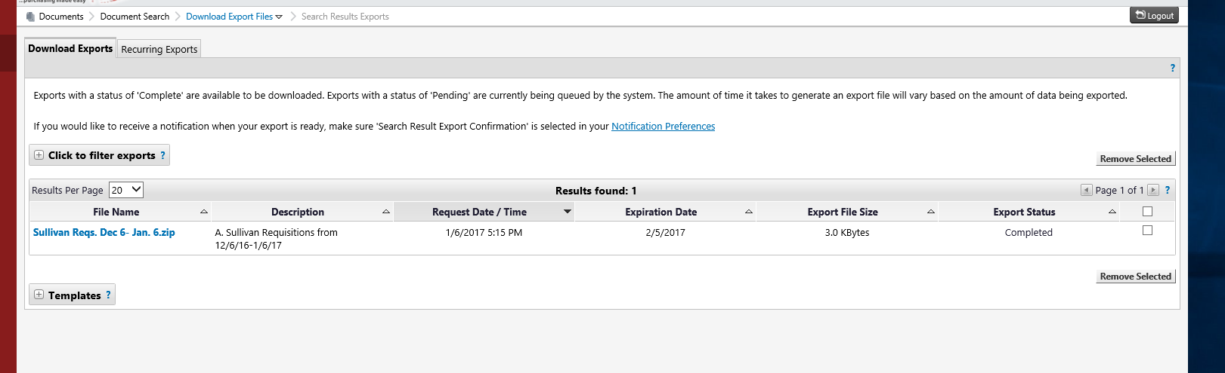

- Two excel spreadsheets will be returned:

- The first returns the data for the requisition summary-

- The second spreadsheet returns the data entered on the ProCard form for the requisition-

