BuyWays Invoice Approval

Invoice approval in Buyways should be considered a confirmation of goods or services rather than an approval since the purchase has already been approved through purchase requisition workflow. An email is sent by Buyways when an invoice has been submitted that needs your approval. The subject line will appear similar to this:

Open the email and follow the link contained at the bottom of the message. It will bring you to your approval list. Click on the voucher to open it. If you need to see a copy of the actual invoice click on the attachments tab and open the attached file or click on the link at the top of the page next to Invoice Image.
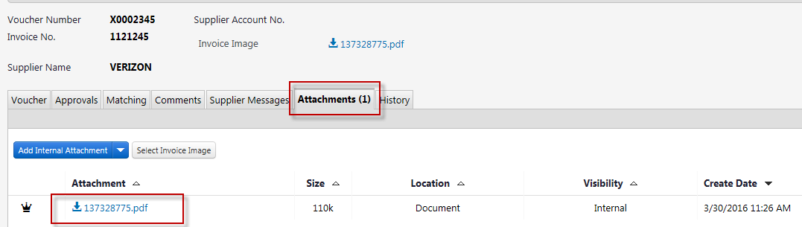

It is a good idea to check the matching tab prior to approving an invoice. This will show whether the price or amount is different than the PO price or amount:
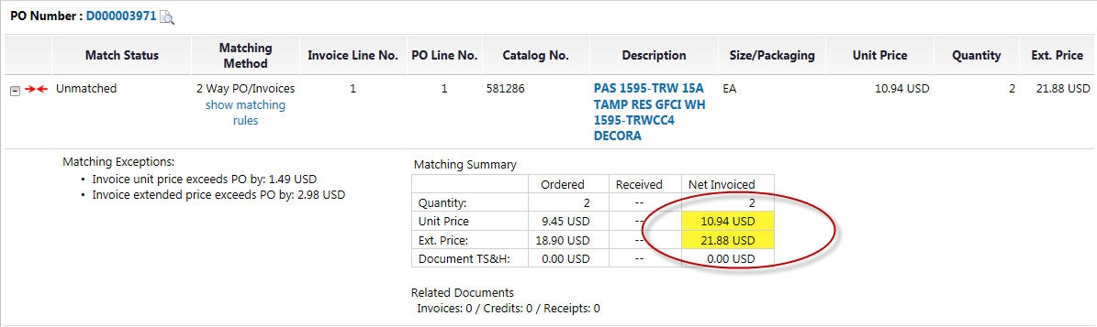

If you approve the overage then you should make a comment indicating that you are aware of the price difference. If the PO is a blanket PO that will have future invoicing please process a change order to increase the PO prior to approving the invoice.

If the invoice is okay to pay go to the upper right side of the page and choose an Approve option from the list. You can choose Approve/complete step to simply approve the voucher or you can choose Approve/complete step & show next if you have multiple invoices that require your approval.
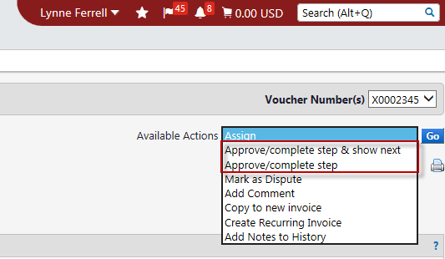
Notes – You can also access your approvals by clicking here:

Or navigating here:

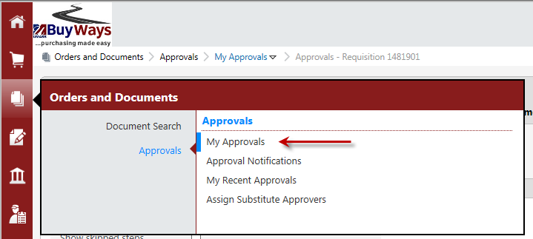

If an invoice requires that someone else review and approve it the invoice can be forwarded.

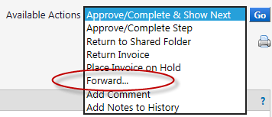

If the invoice has errors or needs editing a comment can be sent to AP requesting to make edits or to reject or cancel the voucher. The comment should be sent to Paula Cassanelli or Lynne Ferrell. They are able to make the edits while the invoice is still in your approval list. Do not approve the voucher if the voucher requires an edit or needs to be rejected or cancelled.

